New Gen Wrapper System Messaging
Aaron Swift, Alex Zavala, Carlos Guzman
2/16/2015
New wrapping system CAN context diagram
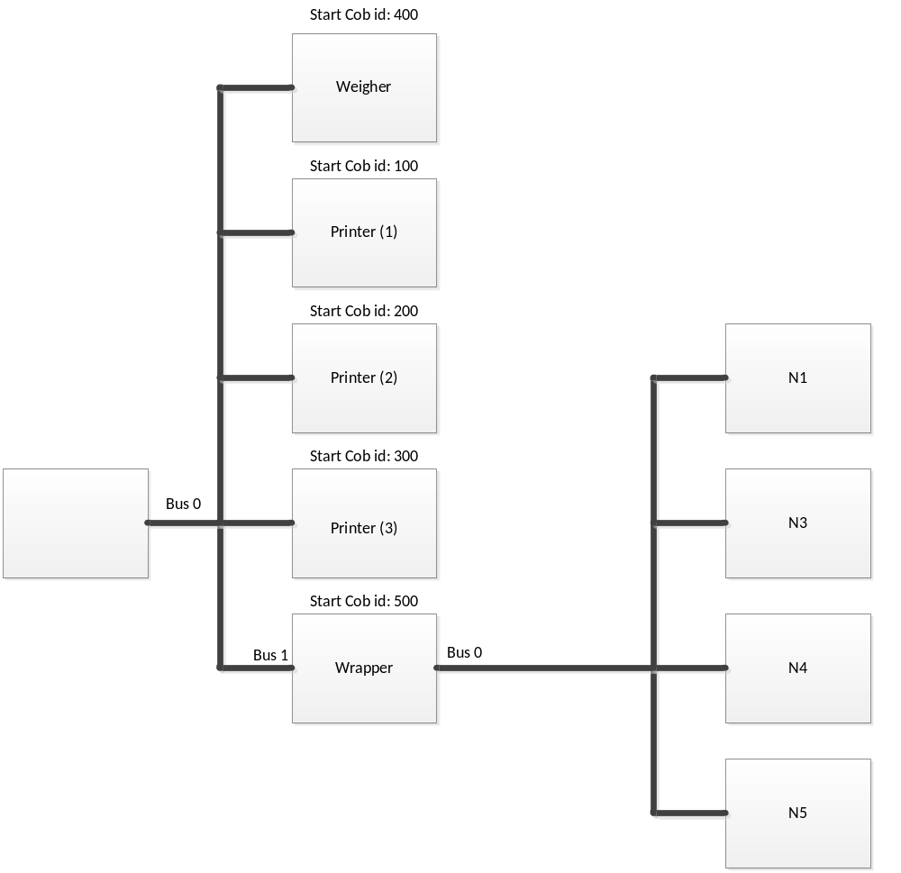

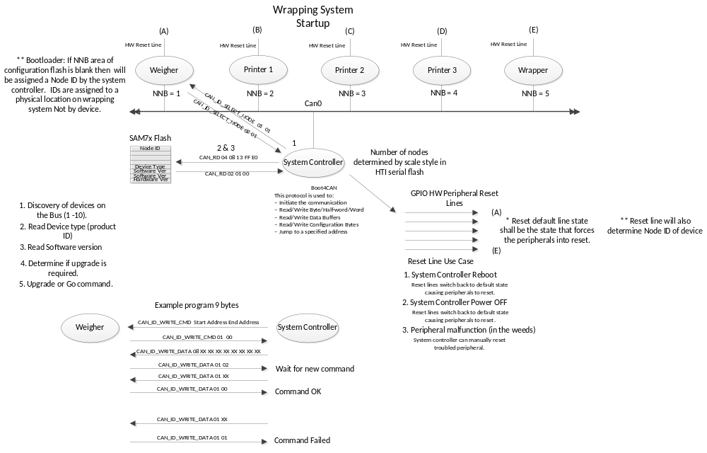
#candump of bootsequence:
can0 000 [1] FF <-- open communication interface
can0 000 [2] 01 01 --> communication interface open
can0 004 [5] 06 00 10 80 00 <-- read vendor id
can0 004 [2] 12 8C --> hobart vendor id
can0 004 [5] 06 00 10 80 02 <-- read product id
can0 004 [2] 04 01 --> weigher product id
can0 004 [5] 06 00 13 FF E0 <-- read major software version
can0 004 [2] 01 00 --> weigher major software version
can0 004 [5] 06 00 13 FF E2 <-- read minor software version
can0 004 [2] 00 00 --> weigher minor software version
can0 006 [2] 00 00 --> read board node id
can0 006 [1] 00 <-- board node id
can0 006 [3] 01 00 04 --> program board node id
can0 006 [1] 00 <-- programmed OK
can0 006 [2] 00 00 --> read board node id
can0 006 [1] 04 <-- board node id
can0 006 [4] 02 10 82 00 --> jump to weigher application
Exiting bootloader

can0 000 [1] FF <-- open communication interface
can0 000 [2] 01 01 --> communication interface open
can0 004 [5] 06 00 10 80 00 <-- read vendor id
can0 004 [2] 12 8C --> hobart vendor id
can0 004 [5] 06 00 10 80 02 <-- read product id
can0 004 [2] 02 05 --> printer product id
can0 004 [5] 06 00 13 FF E0 <-- read major software version
can0 004 [2] 01 00 --> printer major software version
can0 004 [5] 06 00 13 FF E2 <-- read minor software version
can0 004 [2] 00 00 --> printer minor software version
can0 006 [2] 00 00 --> read board node id
can0 006 [1] 00 <-- board node id
can0 006 [3] 01 00 01 --> program board node id (first printer)
can0 006 [1] 00 <-- programmed OK
can0 006 [2] 00 00 <-- read board node id
can0 006 [1] 01 --> board node id
can0 006 [4] 02 10 82 00 --> jump to weigher application
Exiting bootloader

CanManager->probeBus()

CAN messaging schemes
The arbitration field is 11 bits wide which gives us a range of COB IDs from 0 – 7FF.
- Each Hobart peripheral message greater than 8 bytes is spread to the individual receive mailboxes.
Peripheral will round robin message boxes until complete message is transferred.

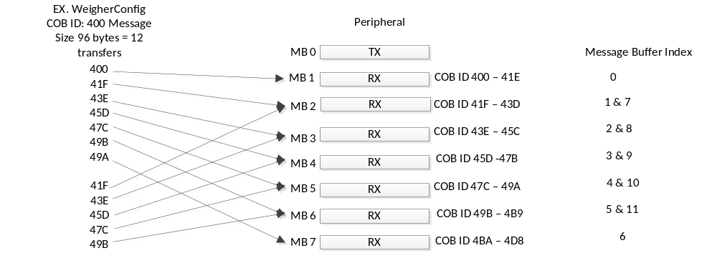

Each Hobart peripheral individual message will have a unique COBID (message box). Messages greater than 8 bytes will send the same ID until message transfer is complete. Scheme 2 was chosen due to ease of implementation.

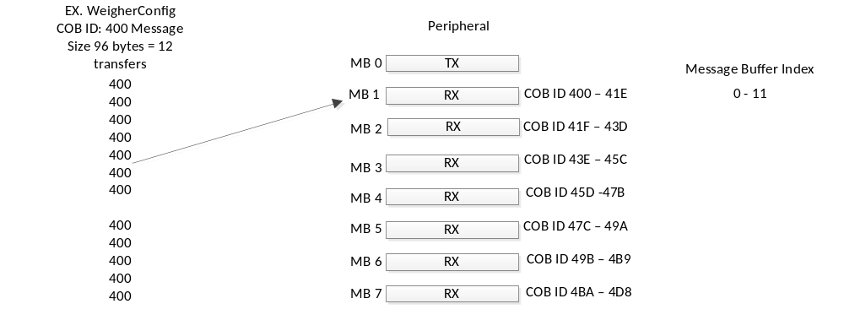

- Each Hobart peripheral message will be start with a header COBID that will contain the type of message the size of the message and the starting and ending COBID’s. This is the same as scheme 1 but with overhead of a message header sent first. Message header format would be Message type, size and the start and stop COBID’s.

The SAM7x CAN interface has 8 mailboxes which can be programmed for TX/RX and a range of COB ID’s can be assigned to each RX mailbox.
1 mailbox for TX
7 mailboxes for RX
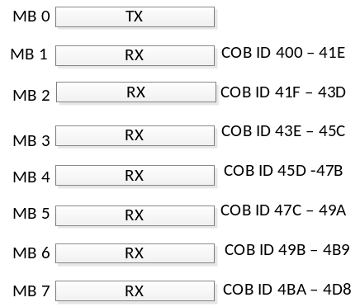

Weigher:

To Weigher
Field Size (Bytes)
WGMode:
ultimaWgMode.function_code
ultimaWgMode.mode Total: 1

WgControl:
ultimaWgControl.function_code
ultimaWgControl.control Total: 1

WgRequestStatus: Total: 1
WgRequestConfig: (Inquire) Total: 1
WgRequestWakeup Total: 1
WgEnable Total: 1
WGDisable Total: 1
WgRezero Total: 1
WgReset Total: 1
WgColdReset Total: 1

WgConfig:
usbWgConfig.function_code
usbWgConfig.configType 2
usbWgConfig.config.ultimaWgCfg.center_of_maintenance_zone 4 usbWgConfig.config.ultimaWgCfg.scale_factor 4
usbWgConfig.config.ultimaWgCfg.max_weight 4
usbWgConfig.config.ultimaWgCfg.gain_factor 4
usbWgConfig.config.ultimaWgCfg.zero_reference 4
usbWgConfig.config.ultimaWgCfg.calibration_reference 4
usbWgConfig.config.ultimaWgCfg.rate_option_time 2
usbWgConfig.config.ultimaWgCfg.auto_zero_maintenance_limit 2
usbWgConfig.config.ultimaWgCfg.prepack_motion_count 2
usbWgConfig.config.ultimaWgCfg.initialize_zero_time 2
usbWgConfig.config.ultimaWgCfg.auto_zero_time 2
usbWgConfig.config.ultimaWgCfg.rate_option_limit 2
usbWgConfig.config.ultimaWgCfg.zero_reference_limit 2
usbWgConfig.config.ultimaWgCfg.calibration_reference_limit 2
usbWgConfig.config.ultimaWgCfg.small_motion_limit 2
usbWgConfig.config.ultimaWgCfg.large_motion_limit 2
usbWgConfig.config.ultimaWgCfg.large_motion_count 2 usbWgConfig.config.ultimaWgCfg.small_motion_count 2
usbWgConfig.config.ultimaWgCfg.no_motion_count 2 usbWgConfig.config.ultimaWgCfg.zero_tracking_option 2
usbWgConfig.config.ultimaWgCfg.negative_weight_option 2 usbWgConfig.config.ultimaWgCfg.powerup_maintenance_zone_limit 2
usbWgConfig.config.ultimaWgCfg.operate_maintenance_zone_limit 2
usbWgConfig.config.ultimaWgCfg.filter_speed 1
usbWgConfig.config.ultimaWgCfg.reference_voltage 1
usbWgConfig.config.ultimaWgCfg.last_calibration_date 4
usbWgConfig.config.ultimaWgCfg.number_of_calibrations 2
usbWgConfig.config.ultimaWgCfg.last_configuration_date 4
usbWgConfig.config.ultimaWgCfg.number_of_configurations 2
usbWgConfig.config.weigher_type 1
usbWgConfig.config.flags 1
usbWgConfig.config.min_weight_to_print 4
usbWgConfig.config.weigher_model 1
Total: 83

** Note message function code no longer necessary the message is now defined by the CAN COB ID.
83 / 8 = 10.5 total transfers

From Weigher:
Message Size (Bytes)
WgWakeup:
UINT8 function_code;
UINT8 pad0;
UINT8 wgCfgStatus; Total: 1

_newWeigherWgStatus:
UINT8 function_code;
UINT8 pad0;
UINT16 status; 2
UINT32 counts; 4
UINT32 raw_counts; 4
UINT32 filtered_uncalibrated_counts; 4
UINT32 AD_counts; 4
Total: 18

_usbWgInquire:
UINT8 function_code;
UINT8 pad0;
UINT16 configType; 2
UINT8 device_signature[SystemDevSignatureSize];
UINT32 center_of_maintenance_zone; 4
UINT32 scale_factor; 4
UINT32 max_weight; /* in calibrated counts */ 4
UINT32 gain_factor; 4
UINT32 zero_reference; 4
UINT32 calibration_reference; 4
UINT16 rate_option_time; /* in seconds */ 2
UINT16 auto_zero_maintenance_limit; 2
UINT16 prepack_motion_count; 2
UINT16 initialize_zero_time; /* in seconds */ 2
UINT16 auto_zero_time; /* in seconds */ 2
UINT16 rate_option_limit; 2
UINT16 zero_reference_limit; 2
UINT16 calibration_reference_limit; 2
UINT16 small_motion_limit; 2
UINT16 large_motion_limit; 2
UINT16 large_motion_count; 2
UINT16 small_motion_count; 2
UINT16 no_motion_count; 2
UINT16 zero_tracking_option; 2
UINT16 negative_weight_option; 2
UINT16 powerup_maintenance_zone_limit; 2
UINT16 operate_maintenance_zone_limit; 2
UINT8 filter_speed; 1
UINT8 reference_voltage; 1
UINT32 last_calibration_date; 4
UINT16 number_of_calibrations; 2
UINT32 last_configuration_date; 4
UINT16 number_of_configurations; 2
UINT8 ntep_cc[ntep_ccSize]; 1
UINT32 calibration_gain_coefficient; 4
UINT32 calibration_offset_coefficient; 4
UINT8 weigher_type; 1
UINT8 load_cell_id; 1
UINT8 flags; 1
UINT32 min_weight_to_print; 4
UINT8 weigher_model; 1
Total: 96

System

SysWakeup:
UINT8 function_code;
UINT8 pad0;
UINT8 sysCfgStatus; Total: 1

SysStatus: (Breakup message)
UINT8 function_code;
UINT8 pad0;
UINT16 bit_error; 2
UINT16 address_error; 2
UINT16 rom_checksum; 2
UINT32 flags; 4
UINT8 partno[PART_NO_SIZE]; 1
UINT16 system_checksum; 2
UINT32 init_flags; 4
UINT16 software_major_revision; 2
UINT16 software_minor_revision; 2
UINT8 hardware_major_revision; // Device ID 1
UINT8 hardware_minor_revision; 1
UINT32 weigher_serial_num; 4
UINT32 DebugFlags; 4
Total: 31
WgReqSerialNumber Total: 1
WgSerialNumber Total: 4
WgReqVersion Total: 1
WgVersion Total: 6

SysConfig: (Inquire) No longer needed
UINT8 function_code;
UINT8 pad0;
UINT16 configType; 2
UINT8 device_signature[SystemDevSignatureSize];
DeviceAddress station_address;
DeviceAddress controller_address;

CAN Messages:
WgRequestWakeup COB ID: 400 Total: 1
WgWakeup COB ID: 401 Total: 1

WgRequestStatus COB ID: 402 Total: 1
WgStatus COB ID: 403 Total: 18
COB ID: 403
COB ID: 403

WgReqSerialNumber COB ID: 404 Total: 1
WgSerialNumber COB ID: 405 Total: 4
WgReqVersion COB ID: 406 Total: 1
WgVersion COB ID: 407 Total: 1

WgRequestConfig: (Inquire) COB ID: 408 Total: 1
WgConfig (usbWgInquire) COB ID: 409 Total: 91
COB ID: 409
COB ID: 409
COB ID: 409
COB ID: 409
COB ID: 409
COB ID: 409
COB ID: 409
COB ID: 409
COB ID: 409
COB ID: 409
COB ID: 409

WgWriteConfig(WgConfig) COB ID: 40A Total: 84
COB ID: 40A
COB ID: 40A
COB ID: 40A
COB ID: 40A
COB ID: 40A
COB ID: 40A
COB ID: 40A
COB ID: 40A
COB ID: 40A
COB ID: 40A

WgMode COB ID: 40B
WgEnable COB ID: 40C Total: 1
WgDisable COB ID: 40D Total: 1
WgRezero COB ID: 40E Total: 1
WgReset COB ID: 40F Total: 1
WgColdReset COB ID: 410 Total: 1
WgControl COB ID: 411 Total: 1

Can Message Format: MSB -> LSB
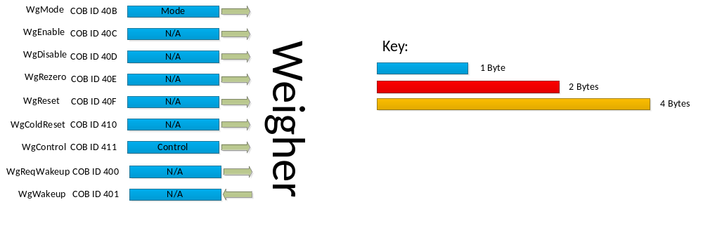

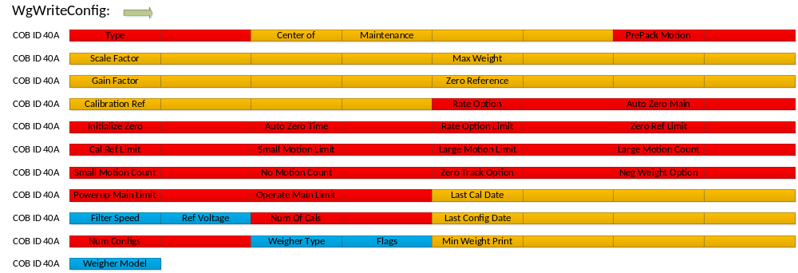
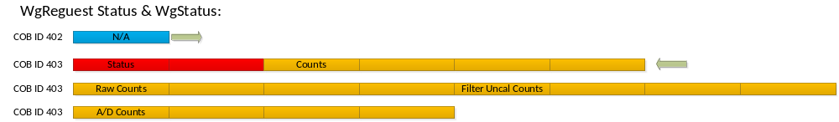
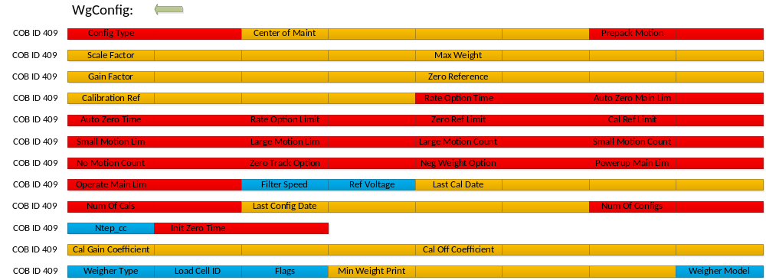

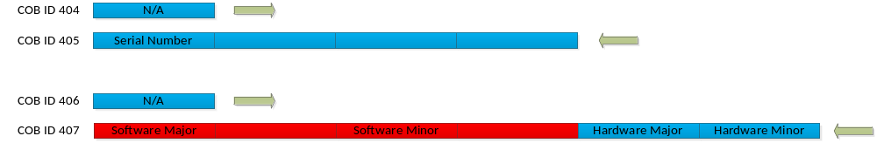

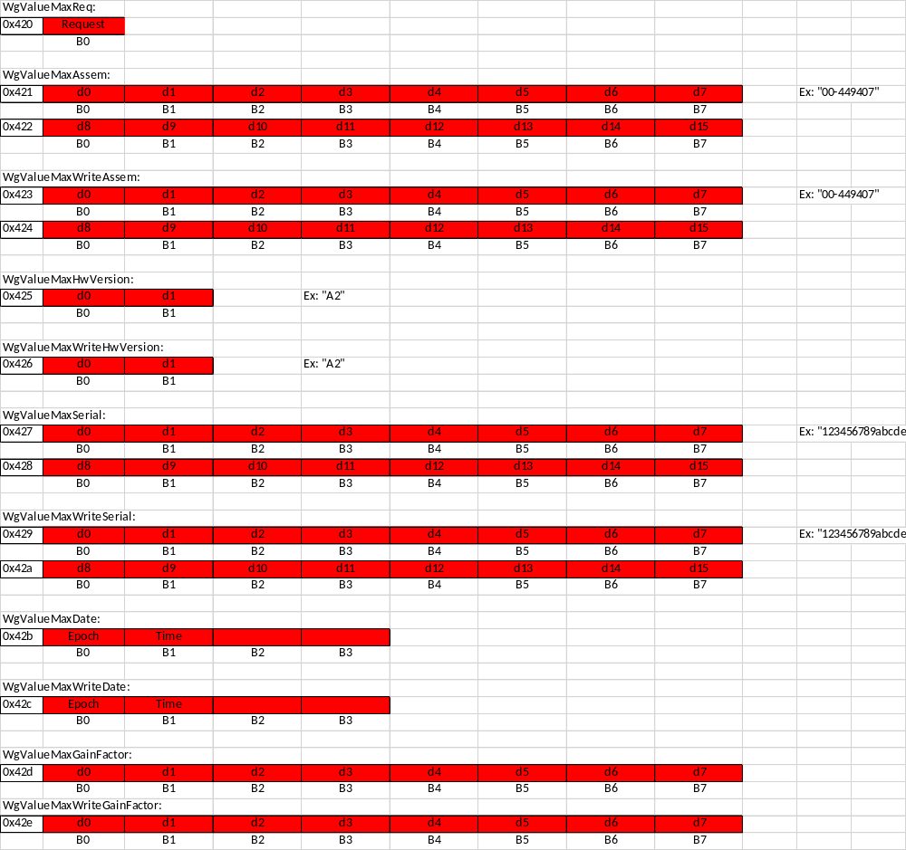

Printer

From Printer: Message Size (Bytes)
** Primary Printer is assigned 100 – 1D8 for COB ID’s
Secondary Printer is assigned 200 – 2D8
Third Printer is assigned 300 – 3D8

PrWakeup:

UINT8 prEvent;
UINT8 pad0;
UINT8 printerType; 1
UINT8 labelWidth; 1
UINT16 bufferSize; 2
UINT16 printheadSize; 2
UINT8 prCfgStatus; 1
Total: 4
PrConfig: (Inquire)
UINT8 prEvent;
UINT8 pad0;
UINT16 prConfigType; 2
UINT8 deviceSignature[SystemDevSignatureSize];
UINT8 printerType; 1
UINT8 labelWidth; 1
UINT8 mediaSensorAdjustment; 1
UINT8 outOfMediaCount; // Immutable!! Set to 200 on Ultima 1
UINT16 printContrast; // "Print Contrast" on Ultima Configuration. 2
UINT16 configWord0; // Used on "European" labels 2
UINT16 configWord1; // Used on "European" labels 2
UINT16 configWord2; // Used on "European" labels 2
UINT16 configWord3; // "Expel Position" on Ultima Configuration. 2
UINT16 configWord4; // Used on "European" labels 2
UINT16 configWord5; 2
UINT16 configWord6; 2
UINT16 configWord7; 2
UINT16 configWord8; 2
UINT16 configWord9; 2
UINT16 configWord10; 2
UINT16 configWord11; 2
UINT16 configWord12; 2
UINT16 configWord13; 2
UINT16 mediaSensorType; 2
UINT16 slaEjectLine; 2
UINT16 printPosition; 2

Total: 42

PrStatus:

UINT8 prEvent;
UINT8 pad0;
UINT8 state; 1
UINT8 command; 1
UINT8 error; 1
UINT8 history; 1
UINT8 sensor; 1
UINT8 user; 1
UINT16 counter; 1
UINT8 sensorMask; 1
UINT8 userMask; 1
UINT8 sensor2Mask; 1
UINT8 pad1;
UINT8 sla; 1
UINT8 sensor2; 1
Total: 12
PrSensors:
UINT8 prEvent;
UINT8 pad0;
UINT16 headupReading; 2
UINT16 labelWidthReading; 2
UINT16 regulatorTemperatureReading; 2
UINT16 headTemperatureReading; 2
UINT16 headVoltageReading; 2
UINT16 headCurrentReading; 2
UINT16 labelHighAverage; 2
UINT16 labelLowAverage; 2
UINT16 labelThreshold; 2
UINT16 labelReading; 2
UINT16 mediaHighAverage; 2
UINT16 mediaLowAverage; 2
UINT16 mediaThreshold; 2
UINT16 mediaReading; 2
Total: 22

System Messages:
SysWakeup: No longer Needed!

UINT8 function_code;
UINT8 pad0;
UINT8 sysCfgStatus; Total: 1

PrSysStatus: Replaced by Error message and version message

UINT8 function_code;
UINT8 pad0;
UINT16 bit_error; 2
UINT16 address_error; 2
UINT16 rom_checksum; 2
UINT32 flags; 4
UINT8 partno[SystemPartNumberSize]; 10
UINT16 system_checksum; 2
UINT32 init_flags; 4
UINT16 software_major_revision; 2
UINT16 software_minor_revision; 2
UINT8 hardware_major_revision; // Device ID 1
UINT8 hardware_minor_revision; 1
Total: 32

PrSysConfig: No longer Needed

UINT8 function_code;
UINT8 pad0;
UINT16 configType; 2
UINT8 device_signature[SystemDevSignatureSize];
DeviceAddress station_address;
DeviceAddress controller_address;
UINT8 hardware_major_revision; // Device ID 1
UINT8 hardware_minor_revision; 1
Total: 4

SysFlashStatus: No longer needed

UINT8 function_code;
UINT8 pad0;
UINT16 BootCodeMajorRevision; 2
UINT16 BootCodeMinorRevision; 2
UINT16 BootStoredChecksum; 2
UINT16 BootCalculatedChecksum; 2
UINT16 FLUD1MajorRevision; 2
UINT16 FLUD1MinorRevision; 2
UINT16 FLUD1StoredChecksum; 2
UINT16 FLUD1CalculatedChecksum; 2
UINT16 FLUD2MajorRevision; 2
UINT16 FLUD2MinorRevision; 2
UINT16 FLUD2StoredChecksum; 2
UINT16 FLUD2CalculatedChecksum; 2
UINT16 PrinterMajorRevision; 2
UINT16 PrinterMinorRevision; 2
UINT16 PrinterStoredChecksum; 2
UINT16 PrinterCalculatedChecksum; 2
UINT8 FlashManufacturerID; 1
UINT8 FlashDeviceID; 1
UINT8 SelectedFLUD; 1
UINT8 FLUD1Status; 1
UINT8 FLUD2Status; 1
UINT8 BPUpdateFailures; 1
UINT8 F1F2UpdateFailures; 1
UINT8 SysConfigStatus; 1
Total: 40

Message Size (Bytes)
PrConfig / PrWriteConfig:
UINT8 prEvent;
UINT8 pad0;
UINT16 prConfigType; 2
UINT8 deviceSignature[SystemDevSignatureSize];
UINT8 printerType; 1
UINT8 labelWidth; 1
UINT8 mediaSensorAdjustment; 1
UINT8 outOfMediaCount; 1
UINT16 printContrast; 2
UINT16 configWord0; 2
UINT16 configWord1; 2
UINT16 configWord2; 2
UINT16 configWord3; 2
UINT16 configWord4; 2
UINT16 configWord5; 2
UINT16 configWord6; 2
UINT16 configWord7; 2
UINT16 configWord8; 2
UINT16 configWord9; 2
UINT16 configWord10; 2
UINT16 configWord11; 2
UINT16 configWord12; 2
UINT16 configWord13; 2
UINT16 mediaSensorType; 2
UINT16 slaEjectLine; 2
UINT16 printPosition; 2
Total: 42

PrFlush: Total: 1
PrReset: Total: 1
PrEnable: Total: 1
PrDisable: Total: 1

PrMode: Total: 1
UINT8 prEvent;
UINT8 pad0;
UINT8 mode; Total: 1

PrReqVersion: Total: 1
PrVersion:
UINT16 software_major_revision; 2
UINT16 software_minor_revision; 2
UINT8 hardware_major_revision; 1
UINT8 hardware_minor_revision; 1
Total: 6

PrError:
UINT8 error_type 1
UINT8 error_data[7] 7
Total: 8

PrPower:
UINT8 prEvent;
UINT8 pad0;
UINT16 powerState; 2
UINT16 scProtection; 2
Total: 4

PrCommand:

UINT8 prEvent;
UINT8 pad0;
UINT8 printerCommandType; 1
UINT8 printerCommandOptions; 1
UINT16 printerIndirection; 2
UINT16 value; 2
Total: 6

PrRam: Alex: This message is no longer needed.

UINT8 prEvent;
UINT8 pad0;
IndirectDataItem
UINT16 location;
UINT16 value;
ram[PrNumRamLocations]; Total: 512

PrTest:

UINT8 prEvent;
UINT8 pad0;
UINT8 data; Total: 1
UINT8 pad1;

PrNomSize:

UINT8 prEvent;
UINT8 pad0;
UINT16 actualSize; 2
UINT16 measuredSize; 2
Total: 4

PrMask:

UINT8 prEvent;
UINT8 pad0;
UINT8 sensorMask;
UINT8 userMask;
UINT8 sensor2Mask; Total: 3
UINT8 pad1;

** Move Teach tables into the Printer which would eliminate this message!!!!
PrTeach:

UINT8 prEvent;
UINT8 pad0;
UINT16 entries; 2
UINT8 command; 1
UINT8 pad1;
CommandOperationMsg operation[30];
UINT8 commandDirective; 1
UINT8 pad[7];
UINT8 commandDirective; 1
UINT8 pad[7];
UINT8 commandDirective; 1
UINT8 type; 1
UINT16 data; 2
UINT8 labelFeedDirection; 1
UINT8 pad[3];
UINT8 commandDirective; 1
UINT8 type; 1
UINT16 data; 2
UINT8 pad[4];
UINT8 commandDirective; 1
UINT8 type; 1
UINT16 data; 2
UINT8 bitOperation; 1
UINT8 bits; 1
UINT8 result; 1
UINT8 pad;
UINT8 commandDirective; 1
UINT8 type; 1
UINT16 data; 2
UINT8 pad[4];
UINT8 commandDirective; 1
UINT8 bitOperation; 1
UINT8 bits; 1
UINT8 result; 1
UINT8 pad[4];
UINT8 commandDirective; 1
UINT8 bitOperation; 1
UINT8 bits; 1
UINT8 result; 1
UINT8 trueBits; 1
UINT8 falseBits; 1
UINT8 trueAction; 1
UINT8 falseAction; 1
UINT8 commandDirective; 1
UINT8 bitOperator; 1
UINT8 bits; 1
UINT8 pad[5];
UINT8 commandDirective; 1
UINT8 counterOperator; 1
UINT8 pad[6]; Total: 1260

PrReqStatus: Total: 1
PrReqConfig: Total: 1
PrReqWakeup: Total: 1
PrEnableTakeup: Total: 1
PrReqSensors: Total: 1
PrReqCalibrate: Total: 1

PrReqLabelTransfer:

UINT8 prEvent;
UINT8 pad0;
UINT16 bufferSize; Total: 2

The SAM7x CAN interface has 8 mailboxes which can be programmed for TX/RX and a range of COB ID’s can be assigned to each RX mailbox.

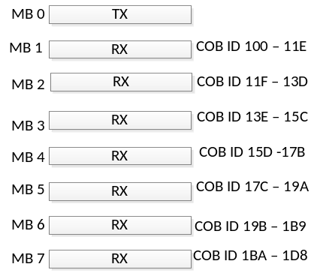

CAN Messages:
Size:
PrReqWakeup: COB ID: 100
PrWakeup COB ID: 101 7
PrReqStatus: COB ID: 102
PrStatus COB ID: 103 12
COB ID: 11F
PrReqConfig: COB ID: 104
PrConfig COB ID: 105 ( 6 frames) 42
COB ID: 105
COB ID: 105
COB ID: 105
COB ID: 105
COB ID: 105

PrWriteConfig COB ID: 106 42
COB ID: 106
COB ID: 106
COB ID: 106
COB ID: 106
COB ID: 106

PrReqSensors: COB ID: 107
PrSensors COB ID: 108 22
COB ID: 108
COB ID: 108

PrFlush COB ID: 109 1
PrReset COB ID: 10A 1
PrEnable COB ID: 10B 1
PrDisable COB ID: 10C 1
PrMode COB ID: 10D 1
PrPower COB ID: 10E 4
PrCommand COB ID: 10F 6
PrTest COB ID: 110 1
PrNomSize COB ID: 111 4
PrMask COB ID: 112 3
PrEnableTakeup: COB ID: 113 1
PrReqCalibrate: COB ID: 114 1
PrReqLabelTransfer: COB ID: 115 2
PrReqVersion COB ID: 116 1
PrVersion COB ID: 117 6
PrLabelTransferStatus COB ID: 118 1

Can Message Format: MSB -> LSB

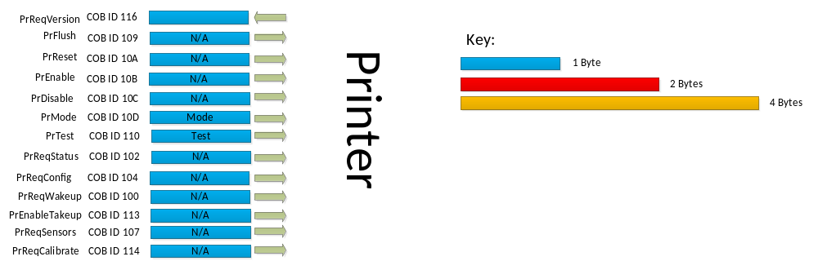

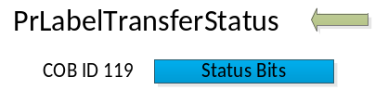

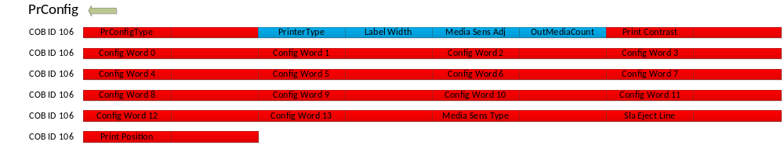

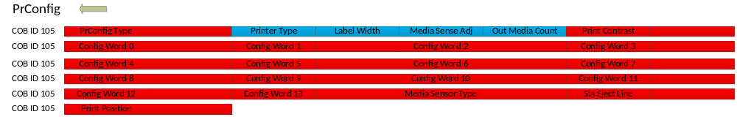

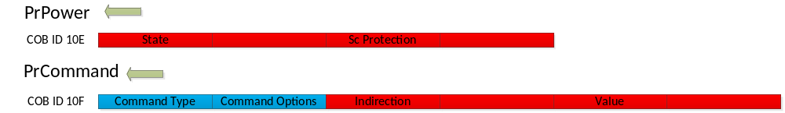

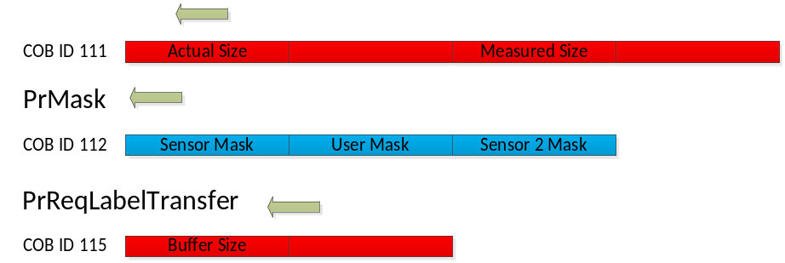

Wrapper

To Wrapper
Size
WrReqWakeup Total: 1
WrEnable Total: 1
WrDisable Total: 1
WrReset Total: 1
WrRequestStatus Total: 1
WrReqConfig(Inquire) Total: 1

WrWriteConfig (WrEvolConfig)
UINT16 functionCode;
UINT16 disposition; 2
UINT16 configVersion; 2
UINT16 pad;
UINT32 checksum; 4
UINT16 isUsed; 2
INT16 maxTemp; 2
INT16 minTemp; 2
UINT16 defaultTempSetting; 2
UINT16 isUsed; 2
INT16 maxTemp; 2
INT16 minTemp; 2
UINT16 defaultTempSetting; 2
UINT32 checksum; 4
UINT16 rollWidth; 2
UINT16 rollDiameter; 2
UINT16 remainingOnRoll; 2
UINT16 rollWidth; 2
UINT16 rollDiameter; 2
UINT16 remainingOnRoll; 2
INT16 wrapperOperation; 2
UINT16 filmTensionNetDefault; 2
UINT16 addOnHardware; 2
INT16 filmTensionServiceAdjust; 2
UINT16 maxPackageWeight; //not in use on AWS -- ats
UINT16 minPackageWeight; //not in use on AWS -- ats
UINT16 maxPackageLength; //not in use on AWS -- ats
UINT16 minPackageLength; //not in use on AWS -- ats
UINT16 maxPackageWidth; //not in use on AWS -- ats
UINT16 minPackageWidth; //not in use on AWS -- ats
UINT16 maxPackageHeight; //not in use on AWS -- ats
UINT16 minPackageHeight; //not in use on AWS -- ats
UINT32 packageGrandTotal; 4
UINT32 wrapperCycleTotal; 4
UINT16 filmTensionFrontToBack; 2
UINT16 filmTensionRightToLeft; 2
UINT32 checksum; 4
UINT16 autoRotation; 2
UINT16 priLabelSizeDefault; 2
UINT16 priLabelWidth; 2
UINT16 priLabelRotationDefault; 2
UINT16 priLabelLocationDefault; 2
INT16 priLabelOffsetOnPkg; 2
UINT16 priRotationCalibrationOffset; 2
UINT16 secLabelSizeDefault; 2
UINT16 secLabelWidth; 2
UINT16 secLabelRotationDefault; 2
UINT16 secLabelLocationDefault; 2
INT16 secLabelOffsetOnPkg; 2
UINT16 secRotationCalibrationOffset; 2
UINT16 secondCLAAttached; 2
UINT16 sideDischargeType; 2
Total: 82

WrWrap
UINT16 wrEvent;
UINT16 intakeMode; 2
UINT16 packageId; 2
UINT16 pullFilm; 2
UINT16 packageWeight; 2
UINT16 pad;
UINT32 pluNumber; 4
Total: 12

WrMode
UINT16 wrEvent;
UINT16 mode; 2
Total: 2

WrControl
UINT16 wrEvent;
UINT16 sealerBeltTempSetting; 2
UINT16 sealerBeltHeaterEnabled; 2
UINT16 filmSupplyTempSetting; 2
UINT16 filmSupplyHeaterEnabled; 2
UINT16 filmTension; 2
UINT16 filmWidthSelection; 2
INT16 filmTensionFrontToBack; 2
INT16 filmTensionRightToLeft; 2
UINT16 intakeMode; 2
Total: 12
WrLoad Total: 0
UINT16 wrEvent;
UINT16 filmWidthSelection; Total: 2

WrRequestPackageTimings
UINT16 wrEvent;
UINT16 param; Total: 2

**Wrap box timing messages Carlos will define**
WrSavePackageTimings TBD
UINT16 wrEvent;
UINT16 disposition; 2
UINT16 wrapBoxes; 2

WrTest
UINT16 wrEvent;
UINT16 testNum; 2
UINT16 data1; 2
UINT16 data2; 2
UINT32 dataLong; 4
Total: 10

WrReqSensors Total: 1
WrRequestCycleCount Total: 1

WrSaveCycleCount
UINT16 wrEvent;
UINT16 pad;
UINT32 cycleCount; Total: 4

WrReqSystemInfo Total: 1
WrSystemInfoErase Total: 1

WrSystemInfoWrite
UINT16 wrEvent;
UINT8 awsSerialNumber[12]; 12
UINT8 awsDateOfManufacture[6]; 6
UINT8 awsDateOfInstall[6]; 6
UINT16 awsModelNumber; 2
UINT32 awsCycleCount; 4
Total: 30

WrReqSystemReset Total: 1

WrReqVersion
UINT16 nodeId 2

From Wrapper
WrWakeup
UINT16 wrEvent;
UINT16 allNodeAvailable; 2
UINT16 wrCfgStatus; 2
UINT16 wrapperOperation; 2
Total: 2
WrStatus (message will be broken up)
UINT16 wrEvent;
UINT16 reportStatus; 2
UINT16 openWindow; 2
UINT16 limpHome; 2
UINT16 wrapperStopped; 2
UINT16 mainPower; 2
UINT16 mainMotor; 2
UINT16 wrapperState; 2
UINT16 primaryConveyor; **current error state 2
UINT16 secondaryConveyor; 2
UINT16 secondaryShift; 2
UINT16 elevator; 2
UINT16 filmSupply; 2
UINT16 gripper; 2
UINT16 knife; 2
UINT16 sideClamp; 2
UINT16 sideFolder; 2
UINT16 rearFolder; 2
UINT16 frontFolder; 2
UINT16 pusher; 2
UINT16 sealerBelt; 2
UINT16 labelApplier; 2
UINT16 generalWrapper; 2
UINT16 primaryConveyor; 2
UINT16 secondaryConveyor; 2
UINT16 secondaryShift; 2
UINT16 elevator; 2
UINT16 filmSupply; 2
UINT16 gripper; 2
UINT16 knife; 2
UINT16 sideClamp; 2
UINT16 sideFolder; 2
UINT16 rearFolder; 2
UINT16 frontFolder; 2
UINT16 pusher; 2
UINT16 sealerBelt; 2
UINT16 labelApplier; 2
UINT16 generalWrapper; 2
UINT16 wrapperMode; 2
UINT16 sealerBeltTemperature; 2
UINT16 sealerBeltSetting; 2
UINT16 sealerBeltStatusBits; 2
UINT16 sealerBeltHeaterEnabled; 2
UINT16 filmTemperature; 2
UINT16 filmSetting; 2
UINT16 filmStatusBits; 2
UINT16 filmTempEnabled; 2
UINT16 ambientTemperature; 2
UINT16 ambientTemperatureStatusBits; 2
EvolWrNodeInternalTemperature nodeBoardTemperature[MaxNodeBoards];
UINT16 internalTemperatureFailed;
Total: 28

WrError
UINT16 Mechanism 2
UINT16 Error Description 2

WrOpen Total: 1

WrConfig
UINT16 functionCode;
UINT16 disposition; 2
UINT16 configVersion; 2
UINT16 pad;
UINT32 checksum 4
UINT16 isUsed; 2
INT16 maxTemp; 2
INT16 minTemp; 2
UINT16 defaultTempSetting; 2
UINT16 isUsed; 2
INT16 maxTemp; 2
INT16 minTemp; 2
UINT16 defaultTempSetting; 2
UINT32 checksum; 4
UINT16 rollWidth; 2
UINT16 rollDiameter; 2
UINT16 remainingOnRoll; 2
UINT16 rollWidth; 2
UINT16 rollDiameter; 2
UINT16 remainingOnRoll; 2
INT16 wrapperOperation; 2
UINT16 filmTensionNetDefault; 2
UINT16 addOnHardware; 2
INT16 filmTensionServiceAdjust; 2
UINT16 maxPackageWeight; //not in use on AWS -- ats
UINT16 minPackageWeight; //not in use on AWS -- ats
UINT16 maxPackageLength; //not in use on AWS -- ats
UINT16 minPackageLength; //not in use on AWS -- ats
UINT16 maxPackageWidth; //not in use on AWS -- ats
UINT16 minPackageWidth; //not in use on AWS -- ats
UINT16 maxPackageHeight; //not in use on AWS -- ats
UINT16 minPackageHeight; //not in use on AWS -- ats
UINT32 packageGrandTotal; 4
UINT32 wrapperCycleTotal; 4
UINT16 filmTensionFrontToBack; 2
UINT16 filmTensionRightToLeft; 2
UINT32 checksum; 4
UINT16 autoRotation; 2
UINT16 priLabelSizeDefault; 2
UINT16 priLabelWidth; 2
UINT16 priLabelRotationDefault; 2
UINT16 priLabelLocationDefault; 2
INT16 priLabelOffsetOnPkg; 2
UINT16 priRotationCalibrationOffset; 2
UINT16 secLabelSizeDefault; 2
UINT16 secLabelWidth; 2
UINT16 secLabelRotationDefault; 2
UINT16 secLabelLocationDefault; 2
INT16 secLabelOffsetOnPkg; 2
UINT16 secRotationCalibrationOffset; 2
UINT16 secondCLAAttached; 2
UINT16 sideDischargeType; 2
Total: 82

WrSysStatus
UINT16 wrEvent;
UINT16 pad0;
UINT16 report_sys_error; 2
UINT16 pad1;
UINT16 nodeid; (**** Times 6 **** 1 for each node) 2
UINT16 config_version; 2
UINT16 device_init_flags; 2
UINT16 major; 2
UINT16 minor; 2
UINT16 major; 2
UINT16 minor; 2
UINT16 major; 2
UINT16 minor; 2
UINT16 pad0;
UINT32 error_flags; 4
UINT32 wrap_box_checksum; 4
Total 26 *6+2 158
WrVersion
UINT16 nodeid 2
UINT16 config_version 2
UINT16 wrap_box_checksum 2
UINT16 boot_major 2
UINT16 boot_minor 2
UINT16 data_major 2
UINT16 data_minor 2
UINT16 app_major 2
UINT16 app_minor 2
Total: 16

WrPkgSettingsRead TBD
WrPkgSettingsWriteComplete TBD

WrTestComplete
UINT16 wrEvent;
UINT16 testNum; 2
UINT16 data1; 2
UINT16 data2; 2
UINT32 dataLong; 4
UINT16 passed; 2
Total: 12

WrSense
UINT16 wrEvent;
UINT16 pad;
UINT32 switchesSensors; 4
UINT16 interlockSwitches; 6
Total: 10

WrPkgDesc
UINT16 wrEvent;
UINT16 id; 2
UINT16 length; 2
UINT16 width; 2
UINT16 height; 2
UINT16 lip; 2
UINT16 filmWidthUsedToWrap; 2
UINT16 wrapBoxIndex; 2
UINT16 heightBoxIndex; 2
UINT16 usedWrapBoxBestFit; 2
UINT16 modifiedNetStretch; 2
Total: 20

WrEventCapture
UINT16 wrEvent;
UINT16 eventCaptureType; 2
UINT16 packageId; 2
UINT16 pad;
UINT32 eventTime; 4
UINT16 pad1;
UINT16 timeLimitExceeded; 2
Total: 10

WrErrHistory
UINT16 wrEvent;
UINT16 wrError; 2
UINT8 trayName[20]; 20
UINT16 packageLength; 2
UINT16 packageWidth; 2
UINT16 packageHeight; 2
UINT16 filmRollUsed; 2
UINT16 usedWrapBoxBestFit; 2
UINT16 modifiedNetStretch; 2
Total: 34

WrWrapCycleCount
UINT16 wrEvent;
UINT16 pad;
UINT32 cycleCount; Total: 4

WrTransferStationDischarging
UINT16 wrEvent;
UINT16 param; Total: 2

WrSysInfo
UINT16 wrEvent;
UINT16 validBoardChecksum; 2
UINT8 motorBoardPartNumber[10]; 10
UINT8 motorBoardRev[2]; 2
UINT8 motorBoardDateOfManufacture[6]; 6
UINT16 validAwsChecksum; 2
UINT8 awsSerialNumber[12]; 12
UINT8 awsDateOfManufacture[6]; 6
UINT8 awsDateOfInstall[6]; 6
UINT16 awsModelNumber; 2
UINT16 pad0;
UINT32 awsCycleCount; 4
Total: 52

WrManufacturingRuninNotice Total: 1

WrMotorProfile
UINT16 wrEvent;
UINT16 bldcMechanism; 2
UINT16 motorStatus; 2
UINT16 motorCapacityUsage; 2
Total: 6

WrLoaderStatus
UINT16 wrEvent;
UINT16 nodeId; 2
UINT16 status; 2
UINT16 fault; 2
UINT16 updateFailureCount; 2
UINT16 softComponent; 2
UINT32 addr; 4
Total: 14

Reformat of WrConfig
NGW_Config
UINT8 Disposition 1
UINT16 configVersion 2
UINT32 checksum 4
INT16 rollwidth 2
INT16 wrapperOperation 2
UINT16 filmTensionNetDefault 2
UINT16 autoRotation 2
UINT16 addOnHardware 2
UINT16 filmTensionFrontToBack 2
UINT16 filmTesionRightToLeft 2
UINT16 secondCLAAttached 2
UINT16 sideDischargeType 2
Total: 25

New Messages
NGW_ApplierConfig
UINT8 applierPosition (primary, secondary) 1
UINT16 labelWidth 2
UINT16 defaultLabelRotation 2
UINT16 defaultLableLocation 2
INT16 labelOffset 2
UINT16 rotationCalibrationOffset 2
Total: 11

NGW_SealerBeltConfig
UINT8 isUsed 1
INT16 maxTemp 2
INT16 minTemp 2
Total: 5

NGW_CycleTotal
UINT32 packageGranTotal 2
UINT32 wrapperCycleTotal 2
Total: 4

WrLabelReady Total: 4
UINT16 Station ID;
UINT16 Package ID;

WrLabelTaken Total: 4
UINT16 StationID;
UINT16 Package ID;

WrLabelSetup
UINT16 laEvent; 2
UINT16 Station ID; 2
UINT16 LabelSize 2
UINT16 LabelRotation; 2
UINT16 LabelLocation; 2
Total: 8

WrWrapperUpdate
UINT16 wrEvent; 2
UINT16 node1; 2
UINT16 update1; 2
UINT16 node3; 2
UINT16 update3; 2
UINT16 node4; 2
UINT16 update4; 2
UINT16 node5; 2
UINT16 update5; 2
UINT16 node6; 2
UINT16 update6; 2
UINT16 node2; 2
UINT16 update2; 2
Total: 24

Wrapper
Cob ID 500 – 700
WrWakeup COBID:500

WrStatus COBID:596
COBID:597
COBID:598
COBID:599

WrConfig COBID:588
COBID:589
COBID:58A
COBID:58B
COBID:58C

WrWriteConfig (WrEvolConfig) COBID:568
COBID:569
COBID:56A
COBID:56B
COBID:56C

WrCycle COBID:506

WrOpen COBID:59d

WrWrap COBID:530
COBID:531

WrMode COBID:539

WrVersion COBID:50A
COBID:50A

WrControl COBID:53A
COBID:53B

WrLoad COBID:511

WrTest COBID:579
COBID:57a

WRSensors COBID:5a7

WrPkgDesc COBID:534
COBID:535
COBID:536

WrEventCapture COBID:594

WrWrapCycleCount COBID:518
WrReqCycleCount COBID:522
WrSaveCycleCount COBID:517

WrReqSystemInfo COBID:566
WrSysInfo COBID:5B0
COBID:5B1
COBID:5B2
COBID:5B3
COBID:5B4
COBID:5B5
COBID:5B6

WrSystemInfoErase COBID:51B
WrSystemInfoWrite COBID:51D

WrReqSystemReset COBID:51F

WrManufactureRuninNotice COBID:5B7

WrMotorProfile COBID:570

WrRequestPackageTimings COBID:521
WrPkgSettingsRead COBID:522
WrPkgSettingsWrite COBID:523
WrPkgSettingsWriteComplete COBID:524

WrErrHistory COBID:5A9
COBID:5AA
COBID:5AB

WrLabelReady COBID:532
WrLabelTaken COBID:533

WrLabelSetup COBID:53C

WrLoaderStatus COBID:5EF
COBID:5EF

WrWrapperUpdate COBID:5F1
COBID:5F1
COBID:5F1

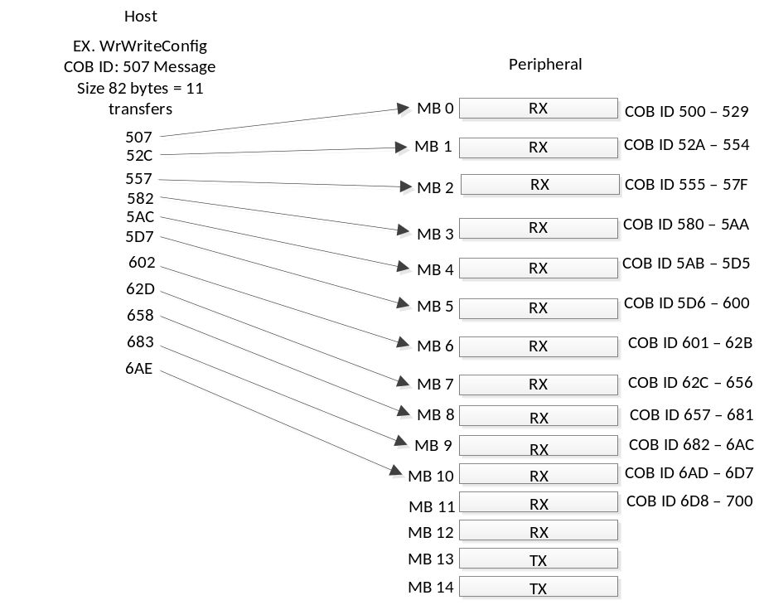

WrRequestWrapBoxAll COBID:541
WrRequestWrapBox COBID:554
WrWrapBox COBID:540
WrWrapBoxComplete COBID:542
WrRequestHeightBox COBID:545
WrHeightBox COBID:544
WrHeightBoxComplete COBID:546
WrChangeParam COBID:547
WrChangeComplete COBID:548
WrTimingsSave COBID:549
WrTimingsSaveComplete COBID:54A

Can Message Format: MSB -> LSB
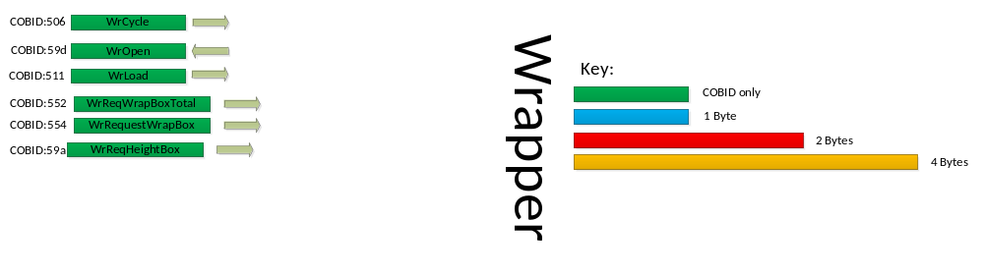
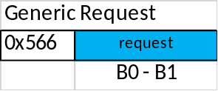
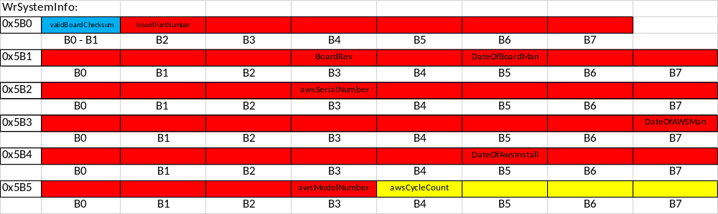
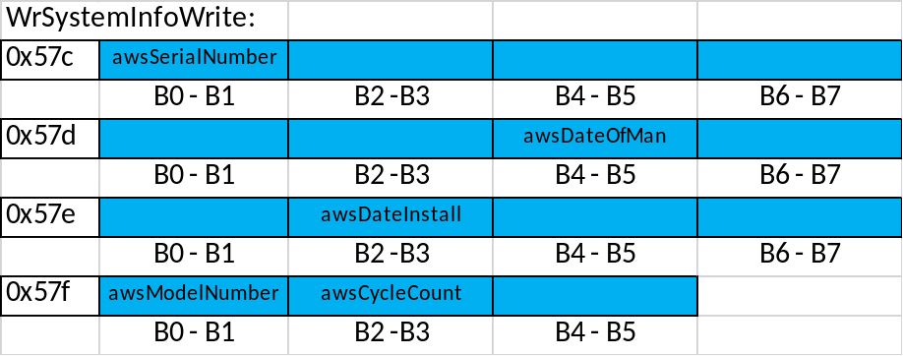

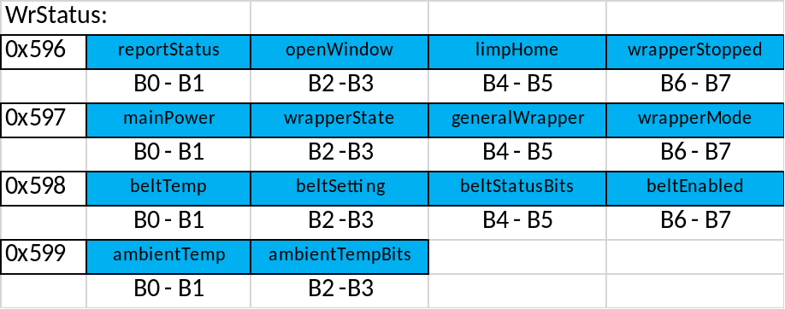
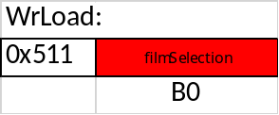
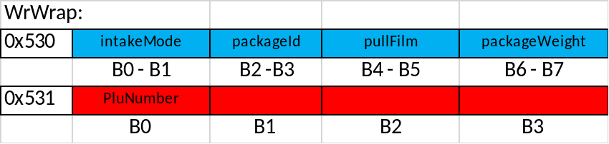
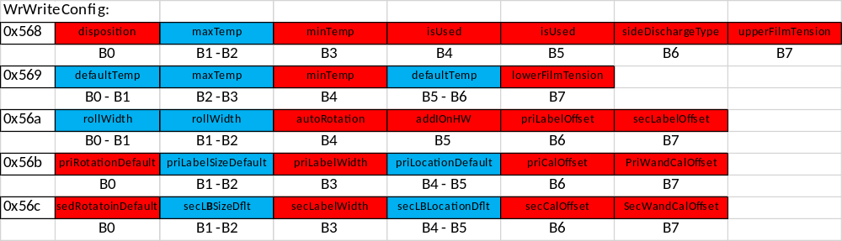
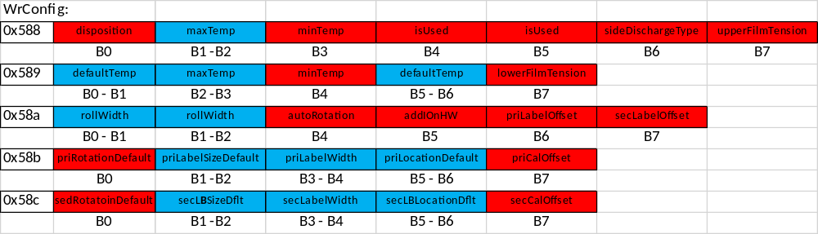

WrPkgDesc:
0x534 | id | length | width | height
 | B0 - B1 | B2 -B3 | B4 - B5 | B6 - B7
0x535 | lip | filmWidthToWrap | wrapboxIndex | heightboxIndex
 | B0 - B1 | B2 -B3 | B4 - B5 | B6 - B7
0x536 | usedBestFit | modNetStretch
 | B0 - B1 | B2 -B3

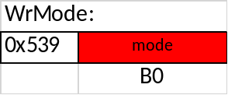
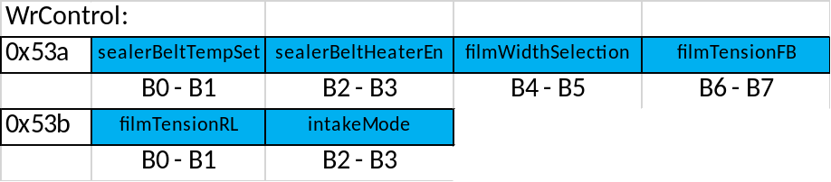
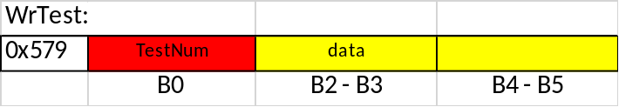
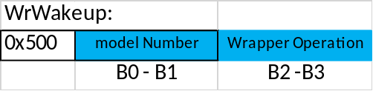
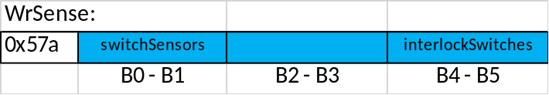
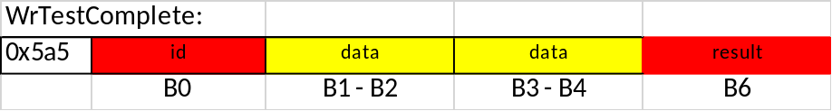

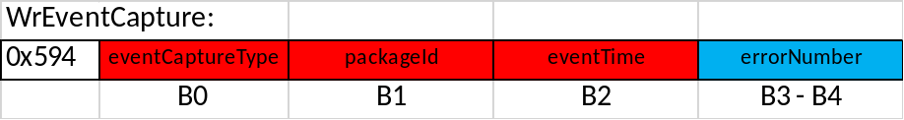
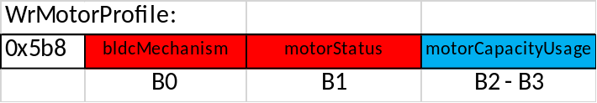
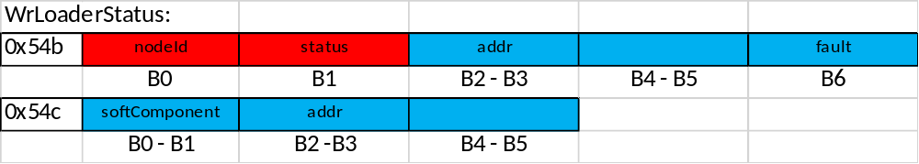
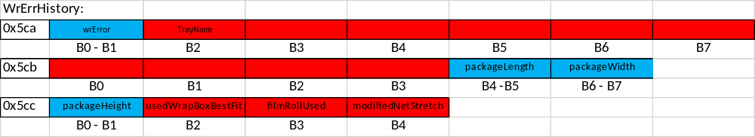

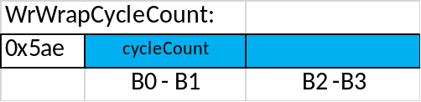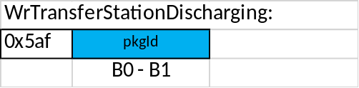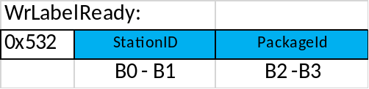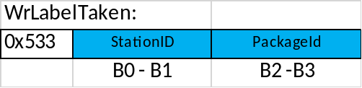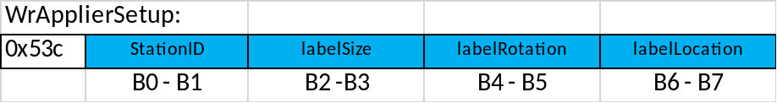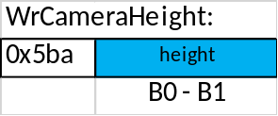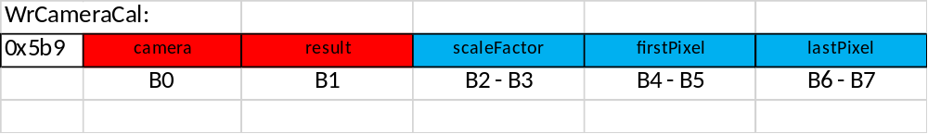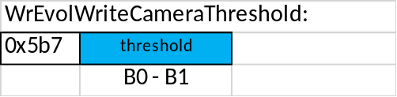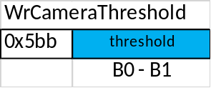
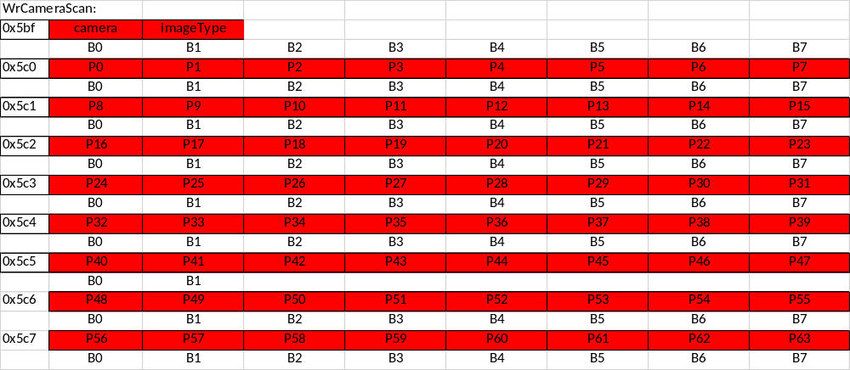
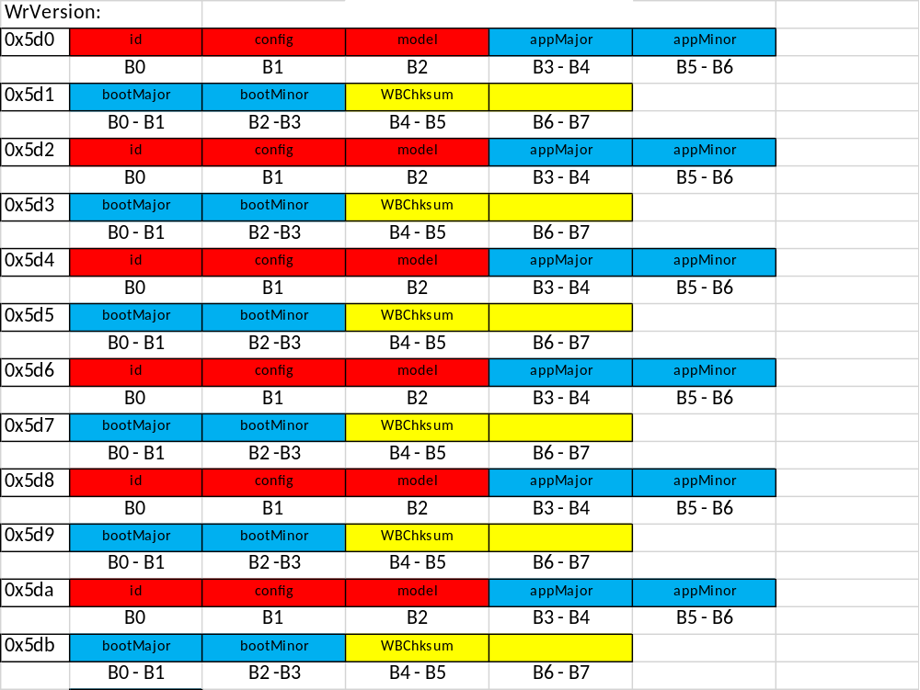

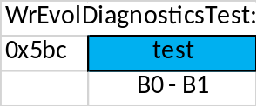

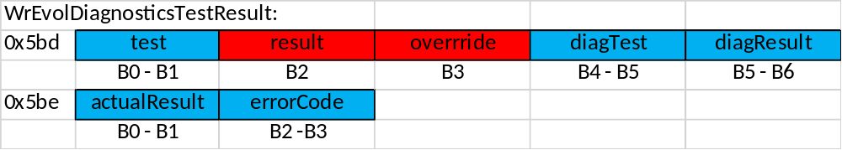

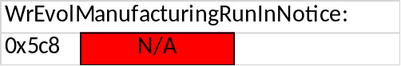

Wrap Boxes:

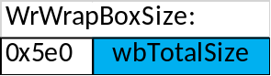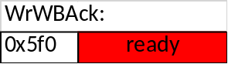

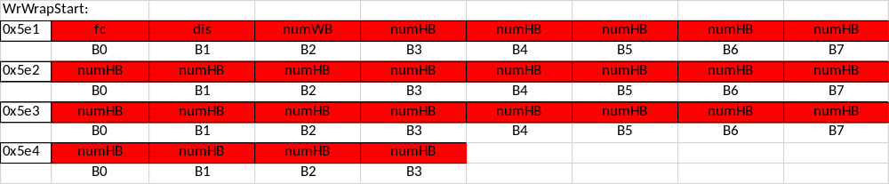
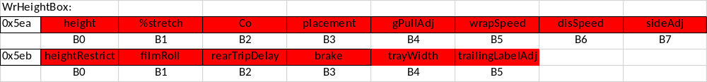
- 28

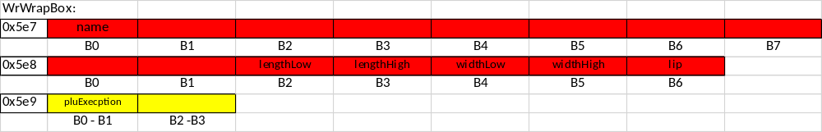

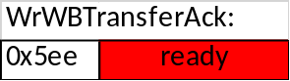

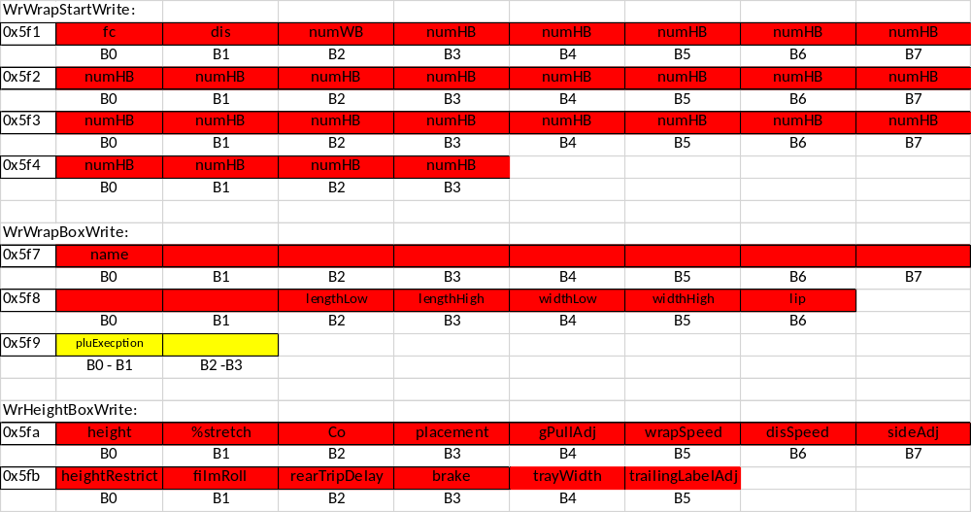

Host Wrap Box Read:
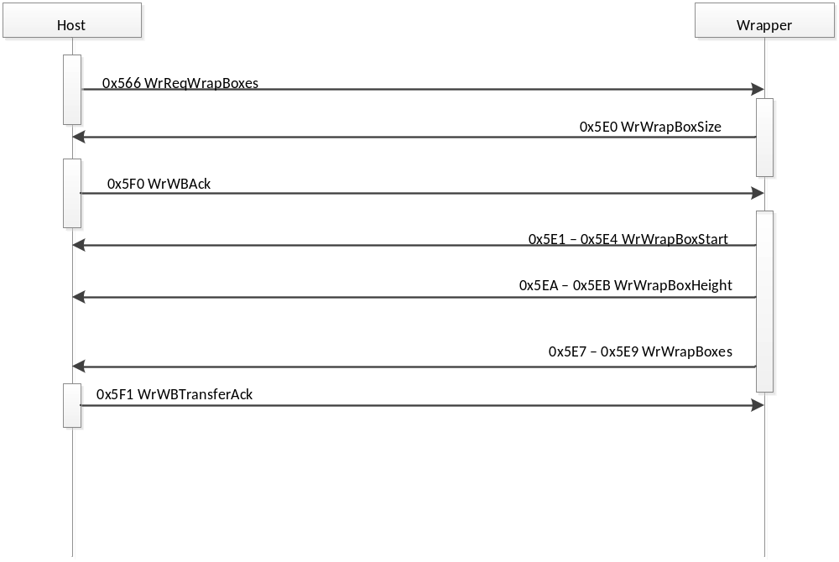

Host Wrap Box Write:

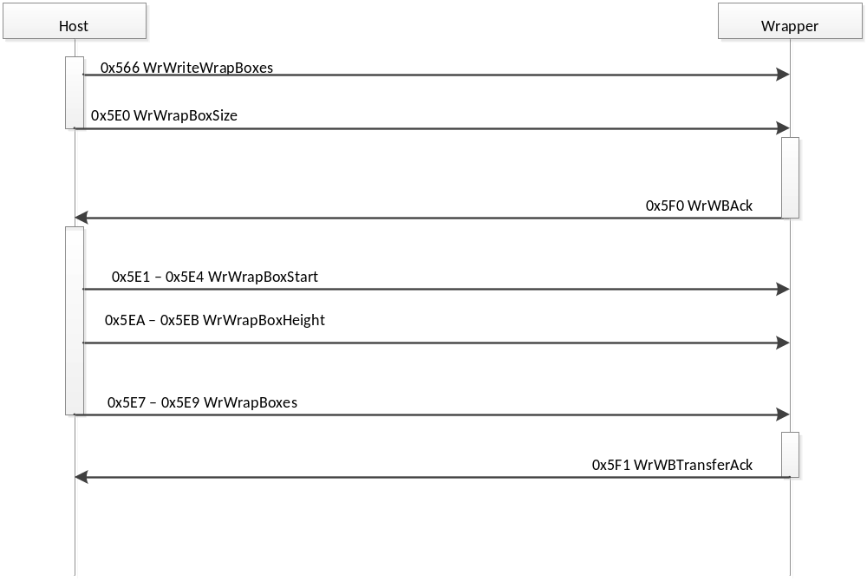

Scale Backend Design:

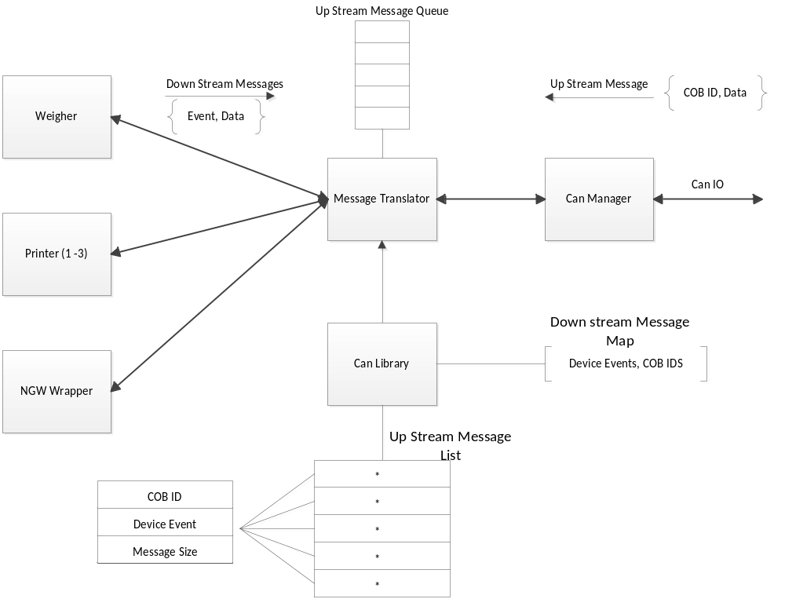

RS485:
This interface is used to transfer the label data image to the printer due to lack of bandwidth on the CAN Bus.
The interface is configured in Asynchronous mode at a baud rate of 3Mb/s. The following is label transfer times using the RS485 interface at 3Mb/s.

Preliminary Results:
Label | Time (mS)
3”x4” | ~225
3”x5” | ~290
3”x6” | ~335
3”x8” | ~450

Transfer of 3 eight inch labels the different printers with in a wrap cycle would require 1.350 Seconds to complete. This time is within our 2 Second spec.

Unit Test Data Scale Backend:

Can Manager Probe:
[Main] Startup CanManager:
[CanManager] Entered CanManager() constructor
[CanManager] Socket ready!!!
[CanTranslator] CanTranslator()
[CanTranslator] Register for Events
[CanLibrary] CanLibrary(): build device libraries.
[CanLibrary] buildWeigherLibrary()
[CanLibrary] buildPrinter1Library()
[CanLibrary] buildPrinter2Library()
[CanLibrary] buildPrinter3Library()
[CanLibrary] buildWrapperLibrary()
[CanManager] initializeTranslator(): initialized!
[CanManager] probeBus()
[CanTranslator] sendWeigherRequest()
[CanLibrary] getWeigherCobID(): 34
[CanTranslator] sendWeigherRequest(): Sending CAN frame: 0400
[CanManager] send():
[CanTranslator] sendPrinterRequest()
[CanTranslator] sendPrinterRequest(): Send CAN Frame: 0100
[CanManager] send():
[CanTranslator] sendPrinterRequest()
[CanTranslator] sendPrinterRequest(): Send CAN Frame: 0200
[CanManager] send():
[CanTranslator] sendPrinterRequest()
[CanTranslator] sendPrinterRequest(): Send CAN Frame: 0300
[CanManager] send():
[CanTranslator] sendWrapperRequest()
[CanTranslator] translateWrapperRequest() Send CAN Frame: 0501
[CanManager] send():

CAN Sniffer:
root@beaglebone-carlos:~# candump can0
can0 400 [1] 00 |
can0 100 [1] 00 |
can0 200 [1] 00 | <-- Bus Probe
can0 300 [1] 00 |
can0 501 [1] 00 |

Weigher Down Stream Messages:
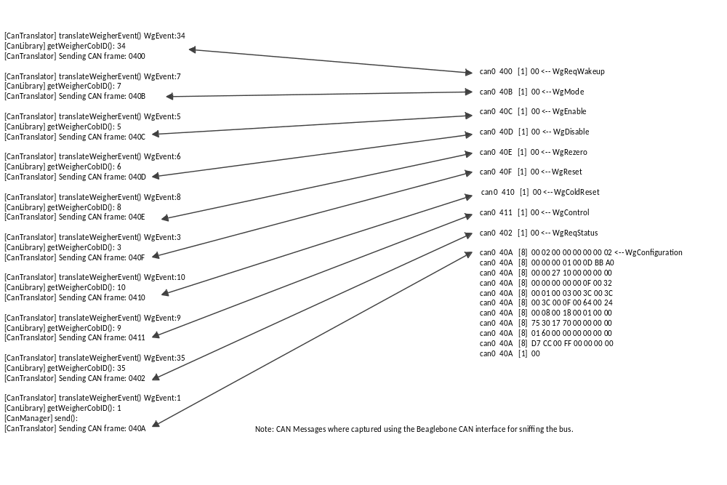

Printer Down Stream Messages:
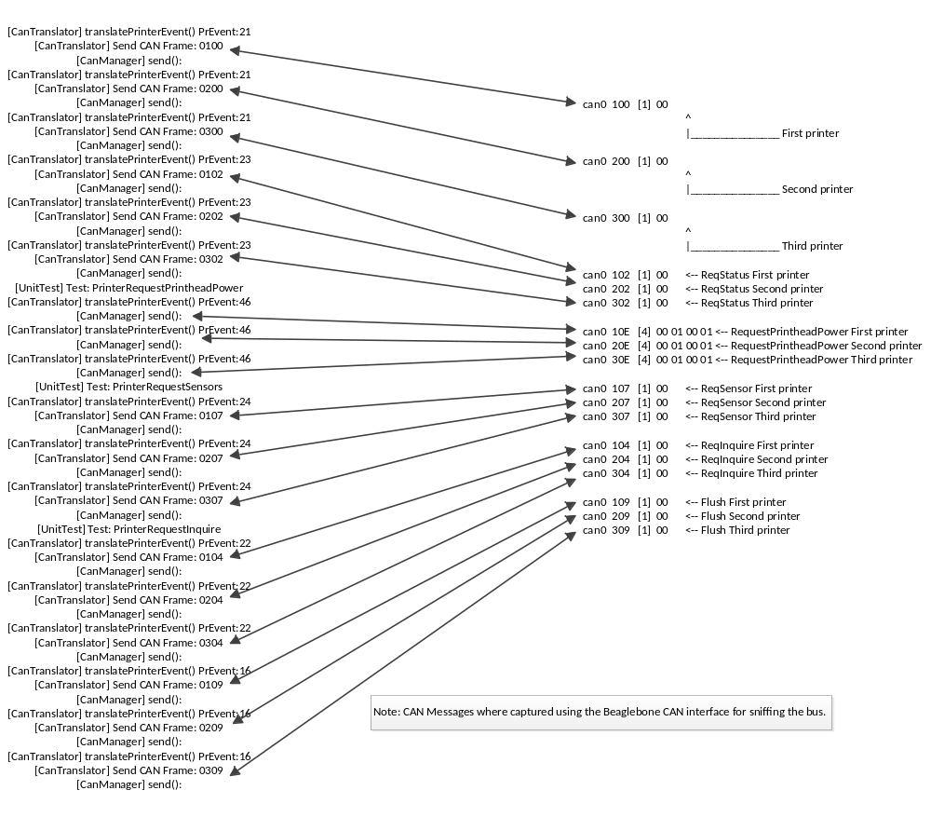

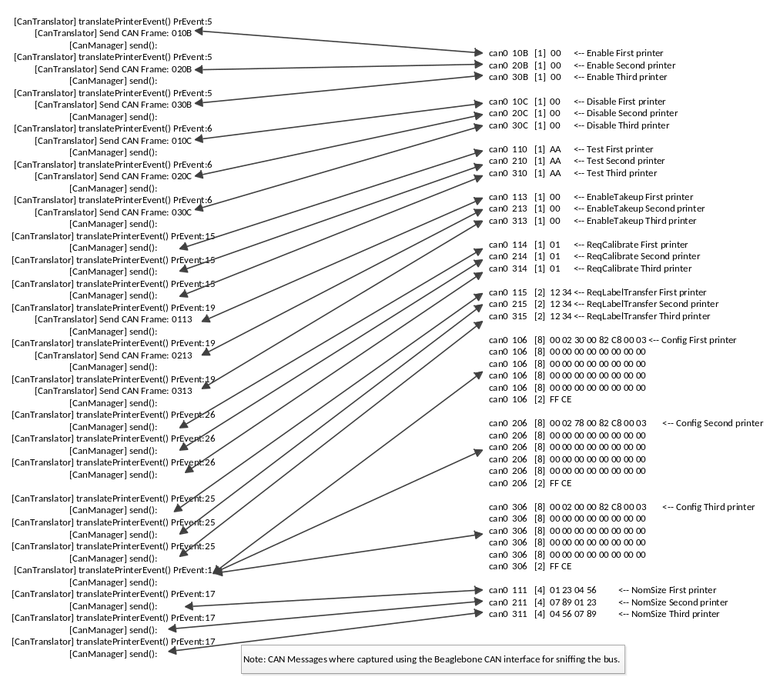

Wrapper Down Stream Messages:
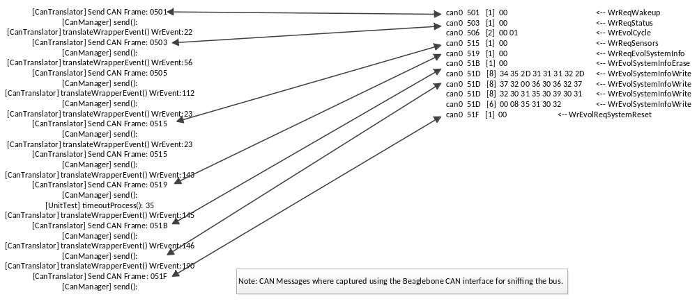

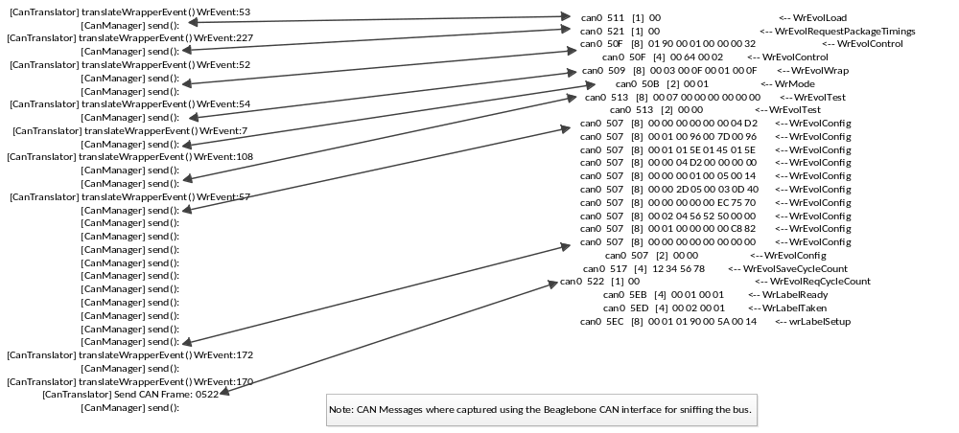

Printer Up Stream Messages:

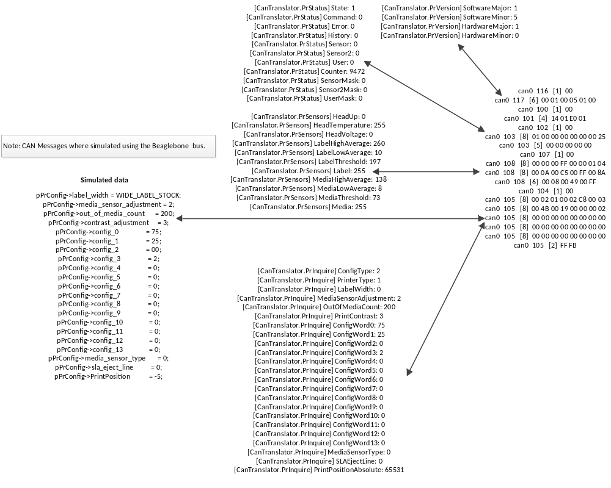

Weigher Up Stream Messages:

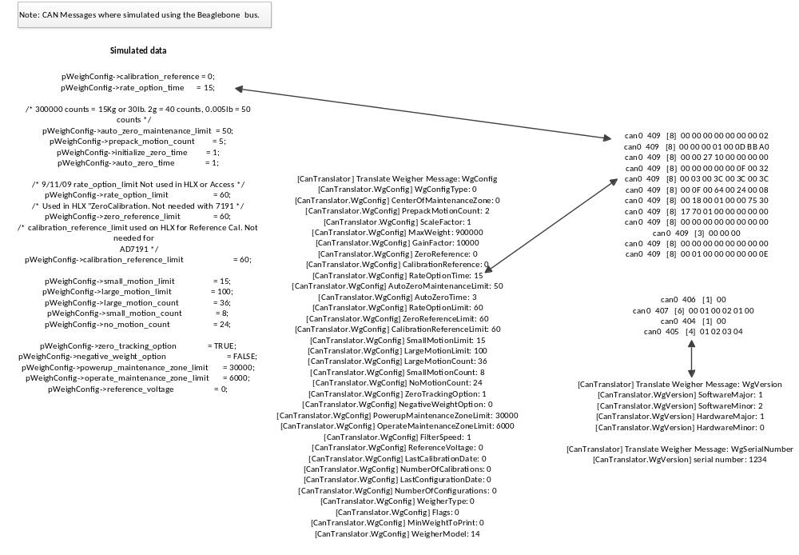

Wrapper Up Stream Messages:

[CanTranslator.WrEvolStatus] ReportStatus: 0 can0 502 [8] 00 00 00 01 00 00 00 00
[CanTranslator.WrEvolStatus] OpenWindow: 1 can0 502 [8] 00 01 00 00 00 00 00 00
[CanTranslator.WrEvolStatus] LimpHome: 0 can0 502 [8] 01 5E 01 5E 00 00 00 01
[CanTranslator.WrEvolStatus] WrapperStopped: 0 can0 502 [4] 00 46 00 00
[CanTranslator.WrEvolStatus] MainPower: 1
[CanTranslator.WrEvolStatus] WrapperState: 0
[CanTranslator.WrEvolStatus] WrapperMode: 0
[CanTranslator.WrEvolStatus] SealerBeltTemp: 0
[CanTranslator.WrEvolStatus] SealerBeltSetting: 350
[CanTranslator.WrEvolStatus] SealerBeltStatusBits: 350
[CanTranslator.WrEvolStatus] SealerBeltHeaterEnabled: 0
[CanTranslator.WrEvolStatus] AmbientTemp: 1
[CanTranslator.WrEvolStatus] AmbientTempStatusBits: 70

[CanTranslator.WrEvolInquire] Checksum: 305419896 can0 504 [8] 00 00 01 01 12 34 56 78
[CanTranslator.WrEvolInquire] IsUsed: 1 can0 504 [8] 00 01 00 96 00 7D 00 96
[CanTranslator.WrEvolInquire] MaxTemp: 150 can0 504 [8] 00 01 01 5E 01 45 01 5E
[CanTranslator.WrEvolInquire] MinTemp: 125 can0 504 [8] 00 00 04 D2 00 00 00 00
[CanTranslator.WrEvolInquire] DefaultTempSetting: 150 can0 504 [8] 00 00 00 01 00 05 00 14
[CanTranslator.WrEvolInquire] IsUsed: 1 can0 504 [8] 00 00 2D 05 00 03 0D 40
[CanTranslator.WrEvolInquire] MaxTemp: 350 can0 504 [8] 00 00 00 00 00 EC 75 70
[CanTranslator.WrEvolInquire] MinTemp: 325 can0 504 [8] 00 02 04 56 52 50 00 00
[CanTranslator.WrEvolInquire] DefaultTempSetting: 350 can0 504 [8] 00 00 00 00 00 00 00 00
[CanTranslator.WrEvolInquire] Checksum: 1234 can0 504 [8] 00 01 00 00 00 00 00 00
[CanTranslator.WrEvolInquire] TopRollWidth: 0 can0 504 [2] 00 00
[CanTranslator.WrEvolInquire] BottomRollWidth: 0
[CanTranslator.WrEvolInquire] WrapperOperation: 0
[CanTranslator.WrEvolInquire] HardwareAddOn: 1
[CanTranslator.WrEvolInquire] FilmTensionFrontToBack: 5
[CanTranslator.WrEvolInquire] FilmTensionRightToLeft: 20
[CanTranslator.WrEvolInquire] PackageGrandTotal: 11525
[CanTranslator.WrEvolInquire] WrapperCycleTotal: 200000
[CanTranslator.WrEvolInquire] Checksum: 0
[CanTranslator.WrEvolInquire] HasAutoRotation: 1
[CanTranslator.WrEvolInquire] PriLabelSizeDefault: 30064
[CanTranslator.WrEvolInquire] PriLabelWidth: 2
[CanTranslator.WrEvolInquire] PriLabelRotationDefault: 1110
[CanTranslator.WrEvolInquire] PriLabelLocationDefault: 21072
[CanTranslator.WrEvolInquire] PriLabelOffsetOnPkg: 0
[CanTranslator.WrEvolInquire] PriRotationCalibrationOffset: 0
[CanTranslator.WrEvolInquire] SecLabelSizeDefault: 0
[CanTranslator.WrEvolInquire] SecLabelWidth: 0
[CanTranslator.WrEvolInquire] SecLabelRotationDefault: 0
[CanTranslator.WrEvolInquire] SecLabelLocationDefault: 1
[CanTranslator.WrEvolInquire] SecLabelOffsetOnPkg: 0
[CanTranslator.WrEvolInquire] SecRotationCalibrationOffset: 0
[CanTranslator.WrEvolInquire] IsSecondCLAAttached: 0
[CanTranslator.WrEvolInquire] SideDischargeType: 0

[CanTranslator.WrEvolPackageDesc] Id: 100
[CanTranslator.WrEvolPackageDesc] Length: 650
[CanTranslator.WrEvolPackageDesc] Width: 400 can0 514 [8] 00 64 02 8A 01 90 00 C8
[CanTranslator.WrEvolPackageDesc] Height: 200 can0 514 [8] 00 64 00 96 00 01 00 02
[CanTranslator.WrEvolPackageDesc] Lip: 100 can0 514 [4] 00 01 00 00
[CanTranslator.WrEvolPackageDesc] WrapBoxIndex: 1
[CanTranslator.WrEvolPackageDesc] HeightBoxIndex: 2
[CanTranslator.WrEvolPackageDesc] UsedWrapBoxBestFit: 1
[CanTranslator.WrEvolPackageDesc] ModifiedNetStretch: 0

[CanTranslator.WrEvolKnifeTime] EventCaptureType: 0 can0 516 [8] 00 00 00 64 00 00 02 6C
[CanTranslator.WrEvolKnifeTime] PackageId: 100 can0 516 [2] 00 96
[CanTranslator.WrEvolKnifeTime] EventTime: 620
[CanTranslator.WrEvolKnifeTime] TimeLimitExceeded: 1

[CanTranslator.WrEvolTestComplete] TestCode: 7 can0 510 [8] 00 07 00 00 00 00 00 01
[CanTranslator.WrEvolTestComplete] Data1: 0 can0 510 [4] 00 00 00 96
[CanTranslator.WrEvolTestComplete] Data2: 0
[CanTranslator.WrEvolTestComplete] TestPassed: 1

[CanTranslator.WrNgwCycleCount] Cycle Count: 150000 can0 518 [4] 00 02 49 F0

[CanTranslator.WrEvolErrorHistory] TrayName: 5S can0 52E [8] 00 0F 35 53 00 00 00 00
[CanTranslator.WrEvolErrorHistory] PackageLength: 400 can0 52E [8] 00 00 00 00 00 00 00 00
[CanTranslator.WrEvolErrorHistory] PackageWidth: 700 can0 52E [8] 00 00 00 00 00 00 01 90
[CanTranslator.WrEvolErrorHistory] PackageHeight: 550 can0 52E [8] 02 BC 02 26 00 01 00 00
[CanTranslator.WrEvolErrorHistory] FilmUsed: 1 can0 52E [2] 00 00
[CanTranslator.WrEvolErrorHistory] UsedBestFit: 0
[CanTranslator.WrEvolErrorHistory] StretchModified: 0

[CanTranslator.WrNgwVersion] NodeId: 1 can0 50A [8] 00 01 01 01 12 34 00 05
[CanTranslator.WrNgwVersion] WrapBoxChecksum: 4660 can0 50A [8] 00 03 00 04 00 00 00 05
[CanTranslator.WrNgwVersion] ConfigVersion: 01.01 can0 50A [2] 00 07
[CanTranslator.WrNgwVersion] BootVersion: 05.03
[CanTranslator.WrNgwVersion] DataVersion:04.00
[CanTranslator.WrNgwVersion] AppVersion:05.07

[CanTranslator.WrNgwError] Mechanism: 3 can0 520 [4] 00 03 00 10
[CanTranslator.WrNgwError] Error: 16

[CanTranslator.WrOpen] Wrapper Open Window can0 508 [1] 00

[CanTranslator.WrManufacturingRunIn] WrManufacturingRunIn can0 530 [1] 00

[CanTranslator.WrEvolSystemInfo] Part# offset: 2 can0 51A [8] 00 01 34 34 35 34 34 30
[CanTranslator.WrEvolSystemInfo] Rev offset: 9 can0 51A [8] 30 30 36 30 31 31 36 31
[CanTranslator.WrEvolSystemInfo] BoardChecksumStatus: 1 can0 51A [8] 32 00 01 30 31 32 33 2D
[CanTranslator.WrEvolSystemInfo] MotorBoardPartNumber: 4454400 can0 51A [8] 34 35 36 37 30 39 31 31
[CanTranslator.WrEvolSystemInfo] MotorBoardRevision: 06 can0 51A [8] 31 34 30 39 31 31 31 35
[CanTranslator.WrEvolSystemInfo] MotorBoardDateOfManufacture: 011612 can0 51A [6] 00 07 00 00 00 64
[CanTranslator.WrEvolSystemInfo] NGWChecksumStatus: 1
[CanTranslator.WrEvolSystemInfo] NGWSerialNumber: 0123-4567
[CanTranslator.WrEvolSystemInfo] NGWDateOfManufacture: 091114
[CanTranslator.WrEvolSystemInfo] NGWDateOfInstall: 091115
[CanTranslator.WrEvolSystemInfo] ModelNumber: 7
[CanTranslator.WrEvolSystemInfo] NGWCycleCount: 100

## Added extra byte to message Id: 0x532 to check error handling for translator dequque.
[CanTranslator.Error] Message Overrun Id: 0532 Message Size: 10 Total Bytes Received: 11
[CanTranslator] Message Complete, Erase from Queue: 0532

Wrapper Firmware Upgrade:

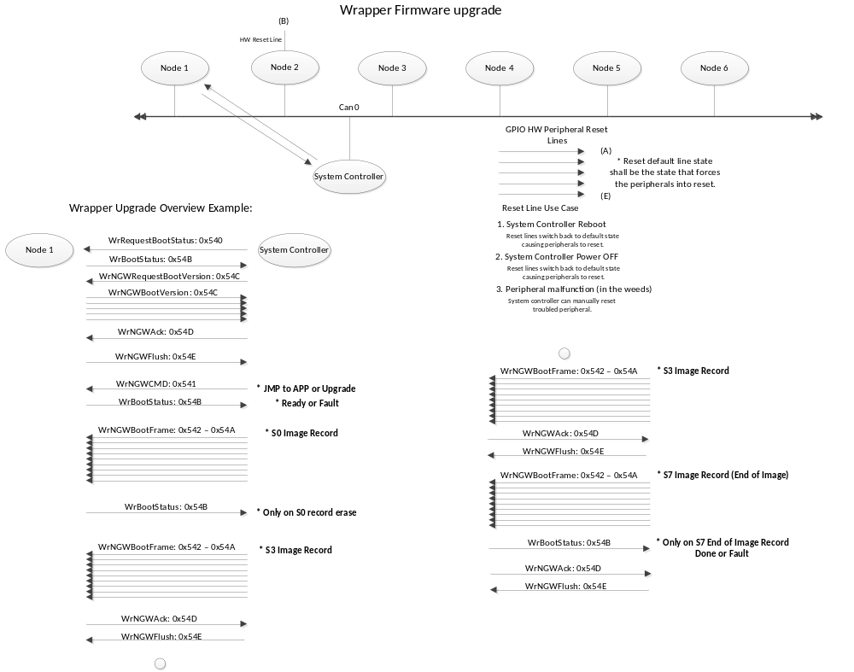

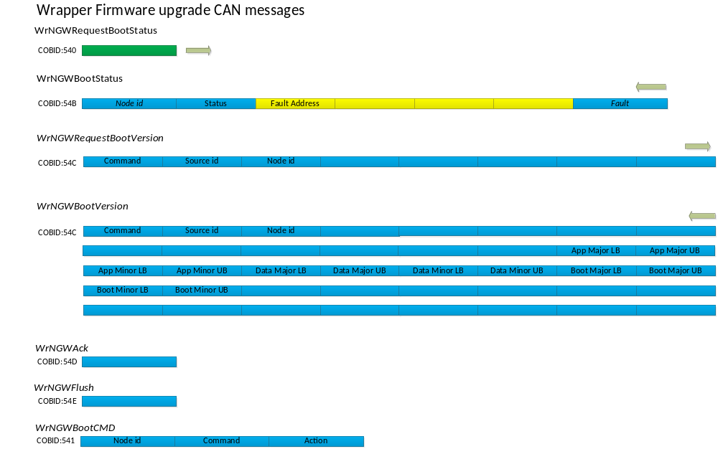

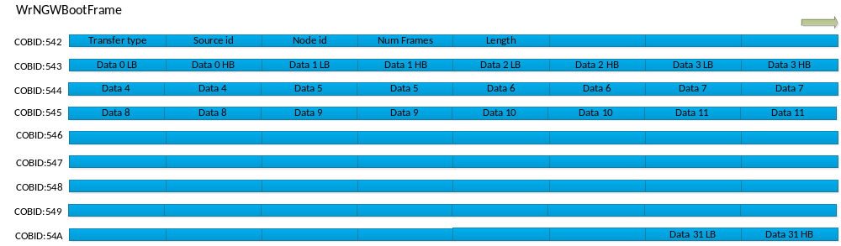

UNIT Test Data: No update files loaded on scale
can0 540 [1] 01 <-- [NGWUpdateManager] Send request for status to node: 1
can0 54B [7] 01 00 00 00 00 00 00 <-- [NGWUpdateManager] Node loader initialized. Switching state to: _RequestVersion
can0 54C [8] 22 FF 01 00 00 00 00 00 <-- [NGWUpdateManager] Send request for version info to node: 1
can0 54C [8] 00 01 02 04 00 00 00 00 <-- [NGWUpdateManager] Version message received for node: 1 Application version: 2.256
can0 543 [8] 00 00 00 00 00 00 00 02
can0 544 [8] 01 00 03 00 01 00 01 00
can0 545 [8] 01 00 00 00 00 00 00 00
can0 546 [8] 00 00 00 00 00 00 00 00 <-- [NGWUpdateManager] No source image found.
can0 541 [3] 01 7C 03 <-- [NGWUpdateManager] Starting node: 1
can0 540 [1] 03 <-- [NGWUpdateManager] Send request for status to node: 3
can0 54B [7] 03 00 00 00 00 00 00 <-- [NGWUpdateManager] Node loader initialized. Switching state to: _RequestVersion
can0 54C [8] 22 FF 03 00 00 00 00 00 <-- [NGWUpdateManager] Send request for version info to node: 3
can0 54C [8] 00 03 02 04 00 00 00 00 <-- [NGWUpdateManager] Version message received for node: 3 Application version: 2.256
can0 543 [8] 00 00 00 00 00 00 00 02
can0 544 [8] 01 00 03 00 01 00 01 00
can0 545 [8] 01 00 00 00 00 00 00 00
can0 546 [8] 00 00 00 00 00 00 00 00 <-- [NGWUpdateManager] No source image found.
can0 541 [3] 03 7C 03 <-- [NGWUpdateManager] Starting node: 3
can0 540 [1] 04 <-- [NGWUpdateManager] Send request for status to node: 4
can0 54B [7] 04 00 00 00 00 00 00 <-- [NGWUpdateManager] Node loader initialized. Switching state to: _RequestVersion
can0 54C [8] 22 FF 04 00 00 00 00 00 <-- [NGWUpdateManager] Send request for version info to node: 4
can0 54C [8] 00 04 02 04 00 00 00 00 <-- [NGWUpdateManager] Version message received for node: 4 Application version: 2.256
can0 543 [8] 00 00 00 00 00 00 00 02
can0 544 [8] 01 00 03 00 01 00 01 00
can0 545 [8] 01 00 00 00 00 00 00 00
can0 546 [8] 00 00 00 00 00 00 00 00 <-- [NGWUpdateManager] No source image found.
can0 541 [3] 04 7C 03 <-- [NGWUpdateManager] Starting node: 4
can0 540 [1] 05 <-- [NGWUpdateManager] Send request for status to node: 5
can0 54B [7] 05 00 00 00 00 00 00 <-- [NGWUpdateManager] Node loader initialized. Switching state to: _RequestVersion
can0 54C [8] 22 FF 05 00 00 00 00 00 <-- [NGWUpdateManager] Send request for version info to node: 5
can0 54C [8] 00 05 02 04 00 00 00 00 <-- [NGWUpdateManager] Version message received for node: 5 Application version: 2.256
can0 543 [8] 00 00 00 00 00 00 00 02
can0 544 [8] 01 00 03 00 01 00 01 00
can0 545 [8] 01 00 00 00 00 00 00 00
can0 546 [8] 00 00 00 00 00 00 00 00 <-- [NGWUpdateManager] No source image found.
can0 541 [3] 05 7C 03 <-- [NGWUpdateManager] Starting node: 5
can0 540 [1] 06 <-- [NGWUpdateManager] Send request for status to node: 6
can0 54B [7] 06 00 00 00 00 00 00 <-- [NGWUpdateManager] Node loader initialized. Switching state to: _RequestVersion
can0 54C [8] 22 FF 06 00 00 00 00 00 <-- [NGWUpdateManager] Send request for version info to node: 6
can0 54C [8] 00 06 02 04 00 00 00 00 <-- [NGWUpdateManager] Version message received for node: 6 Application version: 2.256
can0 543 [8] 00 00 00 00 00 00 00 02
can0 544 [8] 01 00 03 00 01 00 01 00
can0 545 [8] 01 00 00 00 00 00 00 00
can0 546 [8] 00 00 00 00 00 00 00 00 <-- [NGWUpdateManager] No source image found.
can0 541 [3] 06 7C 03 <-- [NGWUpdateManager] Starting node: 6
can0 540 [1] 02 <-- [NGWUpdateManager] Send request for status to node: 2
can0 54B [7] 02 00 00 00 00 00 00 <-- [NGWUpdateManager] Node loader initialized. Switching state to: _RequestVersion
can0 54C [8] 22 FF 02 00 00 00 00 00 <-- [NGWUpdateManager] Send request for version info to node: 2
can0 54C [8] 00 02 02 04 00 00 00 00 <-- [NGWUpdateManager] Version message received for node: 2 Application version: 2.256
can0 543 [8] 00 00 00 00 00 00 00 02
can0 544 [8] 01 00 03 00 01 00 01 00
can0 545 [8] 01 00 00 00 00 00 00 00
can0 546 [8] 00 00 00 00 00 00 00 00 <-- [NGWUpdateManager] No source image found.
can0 541 [3] 02 7C 03 <-- [NGWUpdateManager] Starting node: 2 [NGWUpdateManager] Finished. [NGWUpdateManager] Canceled timer. [NGWUpdateManager] Exiting thread

Upgrade file for node 1 loaded on scale (version 2.256) version matching

can0 540 [1] 01 <-- [NGWUpdateManager] Send request for status to node: 1
can0 54B [7] 01 00 00 00 00 00 00 <-- [NGWUpdateManager] Node loader initialized. Switching state to: _RequestVersion
can0 54C [8] 22 FF 01 00 00 00 00 00 <-- [NGWUpdateManager] Send request for version info to node: 1
can0 54C [8] 00 01 02 04 00 00 00 00 <-- [NGWUpdateManager] Version message received for node: 1 Application version: 2.256
can0 543 [8] 00 00 00 00 00 00 00 02
can0 544 [8] 01 00 03 00 01 00 01 00
can0 545 [8] 01 00 00 00 00 00 00 00
can0 546 [8] 00 00 00 00 00 00 00 00 <-- [NGWUpdateManager] Versions match.
can0 541 [3] 01 7C 03 <-- [NGWUpdateManager] Starting node: 1

Upgrade file for node 1 loaded on scale (version 2.257) only for node upgrade

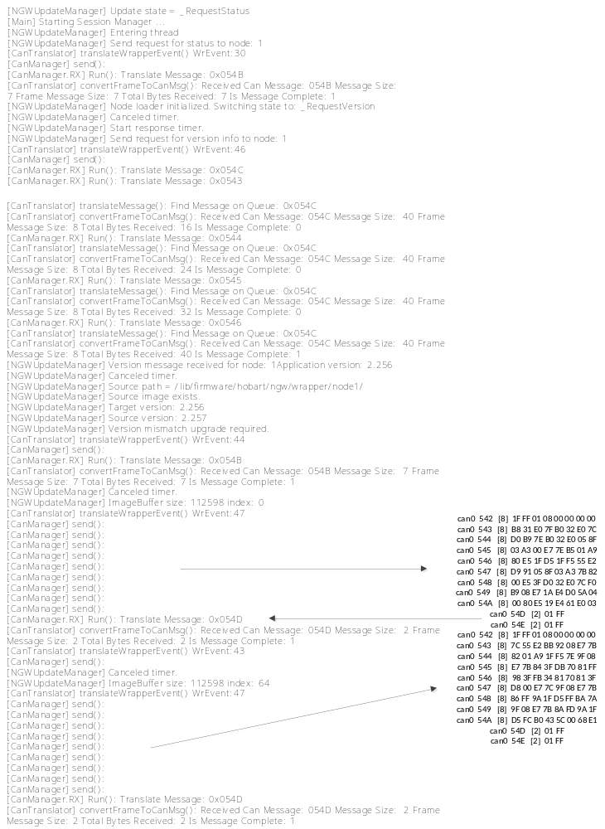

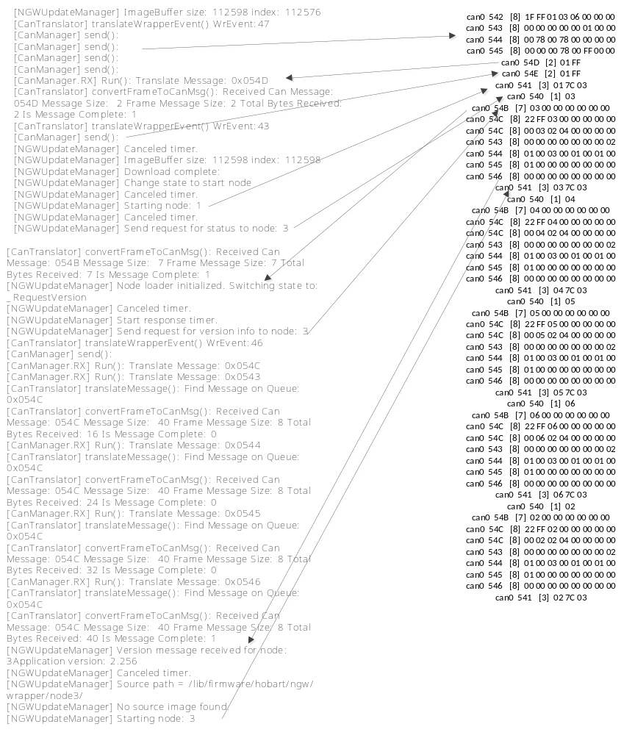

Wrapper bootloader

(011.999675) can0 540 [1] 04 <-- Send request for status to node: 4
(011.999746) can0 54B [7] 04 00 00 00 00 00 00 --> Node 4 status
(012.001914) can0 54C [8] 22 FF 04 00 00 00 00 00 <-- Send request for version info node: 4
(012.001988) can0 54C [8] 23 04 02 00 00 00 00 00 --> Node 4 version info
(012.002138) can0 54C [8] 00 00 00 00 00 00 00 01 --> Node 4 version info
(012.002163) can0 54C [8] 00 00 FF FF FF FF 00 03 --> Node 4 version info
(012.002330) can0 54C [8] 00 00 00 00 00 00 00 00 --> Node 4 version info
(012.002470) can0 54C [8] 00 00 00 00 00 00 00 00 --> Node 4 version info
(012.002837) can0 541 [3] 04 7C 02 <-- Send command to upgrade flash
(012.012616) can0 54B [7] 04 01 00 00 00 00 00 --> Node 4 status ready. ( flash erased without errors )
(012.014608) can0 542 [8] 1F FF 04 08 00 00 00 00 <-- Send bulk transfer header
(012.014964) can0 543 [8] 54 E1 B6 1B 54 E1 B6 1B <-- bytes 0 - 7
(012.015247) can0 544 [8] 54 E2 F5 08 54 E2 F5 08 <-- bytes 8 - 15
(012.015564) can0 545 [8] 54 E2 F5 08 54 E2 9D 09 <-- bytes 16 - 23
(012.015819) can0 546 [8] 54 E2 F5 08 54 E2 F5 08 <-- bytes 24 - 31
(012.016087) can0 547 [8] 54 E2 F5 08 54 E2 F5 08 <-- bytes 32 - 39
(012.016366) can0 548 [8] 54 E2 F5 08 54 E2 F5 08 <-- bytes 40 - 47
(012.016805) can0 549 [8] 54 E2 F5 08 54 E2 F5 08 <-- bytes 48 - 55
(012.017114) can0 54A [8] 54 E2 F5 08 54 E2 F5 08 <-- bytes 56 - 63
(012.017568) can0 54D [4] 04 FF 00 00 --> Node 4 Ack (programmed bulk transfer to flash without error)
(012.018179) can0 54E [2] 04 FF <-- Send Flush command (get ready for next transfer)

16K bytes of data transferred

(012.848759) can0 542 [8] 1F FF 04 08 00 00 00 00 <-- Send bulk transfer header
(012.849038) can0 543 [8] 40 86 05 02 18 E4 2E F0
(012.849339) can0 544 [8] 00 00 40 86 A1 0D 18 E4
(012.849608) can0 545 [8] 36 F0 00 00 40 86 04 00
(012.849879) can0 546 [8] 18 E4 23 F3 00 00 40 86
(012.850150) can0 547 [8] 10 02 18 E4 38 F0 00 00
(012.850452) can0 548 [8] 40 86 5C 82 18 E4 03 F3
(012.850738) can0 549 [8] 00 00 40 86 07 00 54 E1
(012.851010) can0 54A [8] D0 00 08 E7 00 00 00 00
(012.851463) can0 54D [4] 04 FF 00 00

Upgrade time ~= .848 Seconds for 16k bytes of data.
Node flash size: 512k bytes
Total node upgrade time: ( 512 / 16 ) .848 = 27.136 seconds per node
Nodes per machine: 6
Total machine upgrade time: ( 6 * 27.136s ) / 60s = 2.713 Minutes

Uint Test

Invalid Node ID: Remove node id jumper on the node board.
can0 54B [7] 0F 02 00 00 00 00 0A -- > status message ( state = FAULT, fault = Node id error )
Code / Node ID mismatch: Set node jumper to some valid id other than it’s original id. So if code for node 4 is loaded set the jumper id to 3.
can0 54B [7] 03 02 00 00 00 00 08 -- > status message ( state = FAULT, fault = Node image mismatch)

Invalid Image checksum: Modify the application binary so image does not match calculated checksum.
can0 54B [7] 04 02 00 00 00 00 09 -- > status message ( state = FAULT, fault = Image checksum mismatch)

Bootloader timeout: Tell the bootloader to update but do not send image to allow the loader to time out.
can0 54B [7] 04 02 00 00 00 00 01 -- > status message ( state = FAULT, fault = Timeout)

Bootloader reset: Tell the bootloader to reset.
can0 541 [3] 01 7C 04

Jump to application: Instruct bootloader to start application.

Program and jump to: Send valid image to bootloader and instruct to start.
Application

